ThriftLine: A Mobile Thrift Marketplace with a Dynamic Trust and Verification System

Nathaniel Jay S. Bayona  BS Information Technology  University of Mindanao  Matina, Davao City, 8000 n.bayona.544731@umindanao.edu.ph | Razel Joseph P. Ponce  BS Information Technology  University of Mindanao  Matina, Davao City, 8000 r.ponce.550989@umindanao.edu.ph | Dexter B. Ramos  BS Information Technology  University of Mindanao  Matina, Davao City, 8000 d.ramos.544701@umindanao.edu.ph
Meljohn V. Aborde, MIT
University of Mindanao
Matina, Davao City, 8000
mjaborde@umindanao.edu.ph

Categories and Subject Descriptors
Security and privacy → Software and application security → Software security engineering

General Terms
Design, Management, Human, Reliability, Performance

Keywords
Thrift, Mobile Commerce, User Verification, Security and Trust Mechanisms

INTRODUCTION

Project Context
Online thrift shopping has emerged as a rapidly growing segment of the digital commerce industry, providing consumers with an accessible platform for buying and selling second-hand products through online channels. Driven by increasing internet connectivity, mobile technology adoption, and growing interest in affordable and sustainable consumption, online thrift commerce has gained significant popularity among consumers, particularly among younger and budget-conscious markets. In the Philippines, the practice of buying and selling pre-owned items through online platforms has become increasingly common, creating new opportunities for individuals and small-scale entrepreneurs to participate in digital commerce. As the industry continues to expand, online thrift marketplaces play an important role in facilitating convenient transactions, promoting product reuse, and supporting the broader movement toward sustainable and community-driven commerce.
The primary beneficiaries of this study are online thrift shop buyers and sellers who engage in the buying and selling of second-hand products through digital platforms. These individuals range from casual consumers seeking affordable and unique items to small-scale entrepreneurs who operate online thrift businesses as a source of income. In urban communities such as Davao City, online thrift commerce has become increasingly popular due to its accessibility and low barriers to entry, allowing sellers to reach a wider customer base while providing buyers with convenient access to a variety of pre-owned products. As participation in online thrift marketplaces continues to grow, there is an increasing need for platforms that can effectively support the interactions and transactions of both buyers and sellers within a structured digital environment.
Despite the growing popularity of online thrift commerce, buyers and sellers continue to encounter challenges that affect the safety and reliability of their transactions. Most online thrift transactions are conducted through social media platforms and messaging applications, where communication, product inquiries, reservations, and payment arrangements are managed through informal and fragmented channels. This environment often makes it difficult for users to verify the legitimacy of transaction counterparts, increasing the risk of scams, fraudulent activities, bogus buyers, and payment-related disputes. Buyers frequently hesitate to proceed with purchases due to concerns about seller credibility, while sellers face uncertainties regarding the authenticity and commitment of potential buyers. Furthermore, the absence of centralized transaction records and structured transaction management can lead to miscommunication, accountability issues, and difficulties in resolving disputes. As the number of online thrift transactions continues to increase, these challenges have become common concerns among members of the online thrift community, highlighting the need for a more secure and trustworthy digital marketplace environment.
To further validate the identified concerns within the online thrift community, a survey involving 50 online thrift buyers and sellers was conducted. The findings revealed that trust and transaction security remain significant issues in online thrift transactions. Among buyer respondents, 78% agreed that they worry about being scammed when purchasing thrift items online, indicating a high level of concern regarding transaction safety and seller legitimacy. Additionally, 82% of respondents agreed that seller verification would increase their trust in online thrift transactions, while 78% expressed greater confidence in purchasing from verified sellers. The survey also showed strong support for a more structured platform, with 70% of respondents agreeing that a centralized thrift marketplace would improve their overall buying and selling experience. The survey also examined users' experiences with the informal bidding practices commonly used in online thrift selling. The results showed that 70% of respondents agreed that the current bidding process is unclear and stressful, while 68% found waiting without notifications after placing a bid inconvenient. Additionally, 64% preferred a bidding system that provides real-time updates on bid status, and 62% agreed that transparent winner announcements would improve their overall bidding experience. These findings indicate a need for a more structured bidding mechanism capable of providing timely updates, improving transparency, and reducing uncertainty throughout the bidding process. These findings confirm that concerns related to trust, verification, and transaction management are widely experienced within the online thrift community and highlight the need for a secure and reliable platform that can enhance transparency and confidence among users.

Table 1. Matrix of Related Systems
Criterion | Facebook Marketplace | Shopee | Carousell [1] | Tiffany's Online Ukay-Ukay System [2]
User Verification | Facebook profile identity | Phone number and identity verification | Phone verification | Email Authentication
User Reputation | User profile and Account history | Seller ratings and buyer reviews | User ratings and reviews | None
Trust Indicator | Public profile information, marketplace profile | Seller ratings, reviews, response rate | Ratings, reviews, profile history | None
Transaction Protection | None | Escrow-based Buyer Protection and dispute resolution | Buyer Protection (escrow-like payment holding) | Payment integration only
Reporting Mechanism | Report user/listing and block users | Report users, products, and disputes | Report users/listings and block users | None
Transaction Management | Informal messaging-based transactions | Integrated order management and order tracking | In-app transaction management | Product, order, and payment management
Communication Method | Facebook Messenger | In-app chat feature | In-app chat feature | Built-in messaging
Primary Security Approach | Social identity and community reporting | Verification, escrow protection, and transaction monitoring | Reputation system with buyer protection | User authentication and structured transaction records

Table 1 compares the implementation of security-related features across existing online marketplace systems relevant to online thrift commerce. The comparison highlights the different approaches adopted by each platform in establishing user trust, protecting transactions, and managing buyer–seller interactions. Facebook Marketplace primarily relies on users' social identities, publicly visible profiles, account history, and community reporting to help users assess the credibility of transaction counterparts. However, transactions remain largely dependent on personal judgment and external communication channels, providing limited protection against fraudulent users. In contrast, Shopee and Carousell implement more structured security mechanisms through user verification, reputation systems, integrated transaction management, reporting features, and buyer protection services, thereby improving transaction security and user confidence. Meanwhile, Tiffany's Online Ukay-Ukay System [2] focuses on digitizing thrift store operations by providing structured product, order, and payment management but offers limited mechanisms for evaluating user credibility or strengthening transaction trust. Collectively, these systems demonstrate the growing adoption of security-oriented features in online marketplaces. Nevertheless, their implementations primarily emphasize transaction management and transaction protection, while mechanisms capable of proactively evaluating user trustworthiness prior to transactions remain largely absent.
While existing marketplace systems demonstrate the practical implementation of various security features, previous studies provide the theoretical foundation for understanding how trust can be established and maintained in online marketplaces. Trust has consistently been recognized as one of the most influential factors affecting user participation and purchasing behavior in e-commerce. Trust, risk management, and transaction security are identified as fundamental determinants of consumers' willingness to engage in online transactions, emphasizing that users are more likely to transact when appropriate security measures and trust-building mechanisms are present [3]. Similarly, the study Strategy to Enhance Consumer Trust in Online Auctions through Social Media [4] highlights that consumer confidence is influenced by various marketplace trust signals, including reputation indicators, pricing transparency, and social feedback. Together, these studies establish that trust extends beyond secure payment processing and plays a significant role in shaping users' confidence and transaction decisions within online marketplace environments. As online interactions continue beyond a single transaction, recent studies further suggest that trust should not remain static but should continuously evolve based on users' behavior and interactions within the marketplace.
Similar trust-related concerns have also been observed in the Philippine context. It was found that while Filipino consumers value the convenience and affordability of online marketplaces, they remain cautious of fraudulent buyers and sellers, identifying online trust as one of the primary challenges affecting their purchasing experience [5]. Likewise, platform credibility plays a significant role in influencing Filipino consumers' purchase intentions, with transparency emerging as one of the strongest factors contributing to consumer confidence [6]. Their findings further emphasize that authentic and transparent marketplace practices, together with stronger platform regulation, are essential for cultivating trust in the local e-commerce environment. These local findings reinforce the relevance of implementing trust-building mechanisms within Philippine online marketplaces, particularly in peer-to-peer platforms where users frequently transact with unfamiliar individuals.
Building upon the importance of trust in online marketplaces, trust should be adaptive rather than static within social commerce environments [7]. The proposed Adaptive Distributed Consumer Trust Model demonstrates that trust can be continuously refined by integrating multiple sources of trust information and adjusting their influence as new behavioral evidence becomes available. Rather than relying solely on fixed reputation scores or isolated trust indicators, the study emphasizes that user trustworthiness should evolve throughout repeated interactions, allowing trust assessments to more accurately reflect users' current behavior and credibility. Although the model was developed to evaluate consumer trust toward products in social commerce, its adaptive trust concept provides a valuable theoretical foundation for systems that continuously assess user credibility over time. This perspective is particularly relevant to online thrift marketplaces, where buyers and sellers frequently interact with unfamiliar individuals and where trust should evolve according to verified identities, transaction outcomes, and user behavior.
During the review of related literature, the proponents found no existing study that explicitly identifies a specific timeframe or average number of days required to determine whether a user is a scammer in an online marketplace. Most existing research emphasizes that fraudulent behavior cannot be accurately identified based solely on the duration of account activity. Instead, recent studies suggest that user behavior serves as a more reliable indicator for detecting fraudulent activities within online marketplaces. Traditional fraud detection methods that rely only on static account information, such as email addresses, devices, or registered identities, have become increasingly vulnerable because fraudsters can fabricate or manipulate these identifiers [8]. Their study demonstrates that incorporating behavioral data provides a more robust approach to fraud detection, as behavioral patterns are considerably more difficult to imitate or conceal. By continuously analyzing users' interactions and behavioral characteristics, marketplace platforms can more effectively identify suspicious activities and respond to potential fraud. These findings indicate that user credibility should be assessed through continuous behavioral evaluation, together with verification and reputation information, rather than by relying on a predetermined timeframe to identify fraudulent users.
Reputation systems further strengthen trust by providing users with observable indicators of credibility derived from previous interactions. Seller reputation consistently serves as a reliable indicator of trustworthiness and significantly influences transaction outcomes in peer-to-peer online marketplaces [9]. Reputation systems reduce uncertainty between unfamiliar users by providing credibility signals that influence purchasing decisions.However, reputation information itself must remain reliable to effectively support trust. Reputation-based systems are vulnerable to manipulation and fraudulent activities if trust information is not properly validated and managed [10]. Their framework highlights the importance of preserving the integrity of reputation information through mechanisms capable of evaluating user credibility while minimizing opportunities for reputation abuse and misleading trust signals.
Building upon the need for reliable reputation systems, [11] demonstrated that seller reputation not only strengthens consumers' trust in sellers but also reduces perceived transaction risk, ultimately increasing purchase intention within online marketplace platforms. Their findings further emphasize that marketplaces should actively manage seller reputation systems by promoting transparency, maintaining credible seller information, and ensuring that reputation accurately reflects sellers' performance. By improving the management of seller reputation, marketplace platforms can foster greater consumer confidence and encourage more sustainable buyer–seller relationships. These findings reinforce the role of seller reputation as a critical trust signal that enables consumers to make informed purchasing decisions when transacting with unfamiliar sellers.
In addition to seller reputation, the credibility of user-generated reviews plays a significant role in establishing trust within online marketplaces. Consumers' perceptions of fake reviews significantly reduce trust in marketplace rating systems, whereas high-quality and authentic reviews positively influence trust in reviews, reputation systems, and the marketplace itself [12]. Their study further demonstrates that trust established through reliable rating systems contributes directly to a more positive customer experience, highlighting the importance of maintaining review quality and preventing misleading or fraudulent feedback. These findings suggest that reputation systems should not only collect user evaluations but also preserve the authenticity and reliability of review information, allowing consumers to make purchasing decisions based on credible trust signals.
The review of existing systems and related studies reveals several important gaps in current online thrift marketplace platforms. Collectively, the reviewed systems demonstrate significant progress in implementing security features such as user verification, reputation mechanisms, reporting tools, and transaction protection, while the related studies establish the importance of trust, adaptive trust evaluation, reputation management, and authentic review systems in influencing user confidence and online purchasing behavior. However, these contributions remain fragmented. Existing marketplace platforms primarily focus on facilitating secure transactions and managing marketplace operations through isolated security features such as user verification, reputation systems, reporting mechanisms, and payment protection. Meanwhile, recent studies emphasize that trust should be continuously established through adaptive trust evaluation, reliable reputation systems, and credible user reviews. Despite these advances, these trust-building concepts have largely been investigated independently and have yet to be integrated into a unified security framework specifically designed for peer-to-peer online thrift marketplaces. Consequently, there remains an opportunity to develop a platform that combines user verification, dynamic trust evaluation, reputation management, transaction protection, and proactive trust assessment within a unified security framework tailored to peer-to-peer online thrift commerce. Such an approach has the potential to improve transparency, mitigate fraudulent activities, strengthen trust between buyers and sellers, and enhance the overall marketplace experience throughout the transaction process.
To address the identified challenges and gaps, this study proposes the development of ThriftLine, a security-focused mobile thrift marketplace designed to facilitate safer and more reliable online thrift transactions. The system integrates a Dynamic Trust and Verification System that evaluates user credibility through multiple trust indicators, including identity verification, transaction history, seller reputation, user ratings, review-based feedback, and confirmed reports. By combining proactive trust assessment with verification mechanisms, the system aims to help buyers and sellers make more informed decisions before engaging in transactions, thereby reducing the risks associated with scams, fraudulent activities, and untrustworthy users. In addition, ThriftLine provides structured marketplace functionalities such as product listing, transaction management, secure payment protection, and real-time communication features to support efficient and transparent interactions between users. Through the integration of these security-oriented and marketplace functionalities, the proposed system seeks to enhance trust, strengthen transaction security, and improve the overall online thrift shopping experience for both buyers and sellers.

Purpose and Description
This study aims to develop ThriftLine, a centralized mobile-based thrift marketplace designed to provide a secure and organized platform for buying and selling second-hand products online. The proposed system seeks to address common challenges in informal online thrift transactions, including fragmented communication, transaction inefficiencies, and fraudulent activities, by centralizing the buying and selling process into a single platform. The study supports United Nations Sustainable Development Goal (SDG) 9: Industry, Innovation, and Infrastructure by promoting digital innovation in commerce and aligns with the University of Mindanao's research agenda on Information and Communication Technology (ICT)-enabled solutions for organizational and economic development.
The proposed study involves the design and development of ThriftLine, a centralized mobile application that serves as a digital marketplace for second-hand products. The system consists of integrated modules for product listing and browsing, buyer and seller account management, transaction processing, user verification, payment management, and administrative monitoring. It also incorporates a Weighted Sum Model (WSM)-based Dynamic Trust Scoring System as its core decision-support mechanism for evaluating user trustworthiness using predefined assessment criteria. The application is intended for three primary user groups: administrators, sellers, and buyers, each with designated functions and system access based on their respective roles.

Objectives

General Objective
This study aims to develop ThriftLine, a mobile-based thrift marketplace application that enables buyers and sellers to conduct secure, transparent, and trustworthy second-hand online transactions.

Specific Objectives
      - Integrate a Weighted Sum Model (WSM)-based Dynamic Trust and Verification Framework to compute dynamic trust scores based on identity verification, successful transactions, user ratings, and confirmed reports.
      - Design a multi-level user verification mechanism using Supabase Authentication and government-issued identification verification to authenticate users through email, phone number, and identity verification.
      - Implement an escrow-based payment protection mechanism integrated with GCash to temporarily hold buyer payments until transaction conditions are fulfilled.
      - Develop a real-time messaging and item-claiming module using Supabase Realtime to facilitate communication and structured product bidding between buyers and sellers.

Scope and Limitation
This study covers the design and development of ThriftLine, a centralized mobile-based thrift marketplace intended for buying and selling second-hand products within Davao City, Philippines. The system includes modules for user registration and authentication, product listing and browsing, buyer-seller communication, transaction management, payment processing, user verification, administrative monitoring, and delivery coordination. It also integrates a Weighted Sum Model (WSM)-based Dynamic Trust Scoring System to evaluate seller credibility using predefined trust criteria. For shipment coordination, the system supports third-party courier services by allowing sellers to record shipment information, including the selected courier and tracking number, while providing buyers with direct access to the courier's official shipment tracking page through a tracking link. The study encompasses the design, implementation, and functional evaluation of the proposed mobile application involving three primary user roles: Administrator, Seller, and Buyer.

The study is limited to the development and evaluation of a mobile application for an online thrift marketplace and does not cover general retail or international e-commerce operations. The proposed system is intended for users within Davao City, and its functional requirements are based on data gathered from survey respondents and informal interviews conducted within the local thrift community. The application requires a stable internet connection for its core functionalities and relies on third-party service providers for payment processing and shipment coordination. The system does not directly integrate with courier application programming interfaces (APIs) and therefore does not generate or control real-time parcel tracking information. Instead, buyers access shipment updates through the official tracking services of the selected courier using the tracking number provided by the seller. Furthermore, the study focuses on the implementation and functional performance of the system and does not evaluate long-term user adoption, commercial deployment, or the operational performance and accuracy of external payment and courier service providers.

METHODS
This study adopts the Agile Scrum methodology as its software development framework. Agile Scrum structures development into short, iterative cycles called sprints, allowing continuous improvement and flexibility throughout the process. Each sprint follows key activities such as planning, development, testing, and review, ensuring that working features are delivered incrementally. This approach emphasizes collaboration, regular feedback, and adaptability, making it suitable for systems where requirements may evolve over time.
In this project, ThriftLine will be developed through a series of structured sprints covering system architecture, core features (user registration, product listing, order and reservation management), buyer–seller matching, and system integration, followed by testing and deployment. The team will consist of a Product Owner (research adviser proxy), Scrum Master, and Development Team, using tools like Google Workspace (Google Docs, Google Spreadsheet, etc.) for task management, GitHub for version control, and Facebook Messenger for communication. Agile Scrum is chosen over any other models because it better handles changing requirements, reduces development risks through continuous testing, and allows early detection of issues, making it ideal for the project’s scope, timeline, and iterative nature.
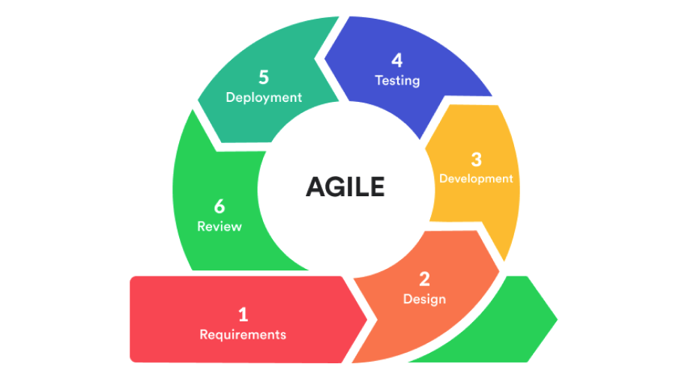
Figure 1. Agile Scrum

Data Gathering
Following the approval of the survey questionnaire by the course adviser during the Technopreneurship course, the proponents immediately commenced the data gathering process. The participants consisted of 50 individuals residing in Davao City who were actively involved in the online thrift shopping community, either as buyers, sellers, or both. These participants were deliberately selected because of their firsthand experience in conducting transactions within online thrift marketplaces, making them the most appropriate source of information regarding the existing practices, challenges, and security concerns associated with online thrift commerce. The survey was conducted online by reaching out to potential participants through Facebook Marketplace and various Facebook thrift shopping groups. Each prospective participant was first informed of the purpose of the study, and their voluntary consent was obtained before they were provided with the Google Forms survey link. Data collection began on April 13, 2026, with the first completed response recorded on that date. The proponents continued distributing the survey and engaging with qualified participants until the target sample size of 50 was achieved on April 24, 2026, resulting in a data gathering period of approximately 12 days. In addition to the online survey, the proponents conducted informal interviews with selected participants to gain deeper qualitative insights into their experiences with online thrift shopping, including their buying and selling processes on social media platforms, as well as the challenges, pain points, and security concerns encountered throughout their transactions.

Analysis
The analysis phase examines the requirements, constraints, and feasibility of the proposed ThriftLine system to ensure that it effectively addresses the identified problems and meets the needs of its intended users. This section presents the user requirements, hardware and software requirements, functional and non-functional requirements, and feasibility study, which serve as the foundation for the system's design and implementation.
2.2.1 User Requirements
The user requirements were identified through interviews, observations, surveys, and an analysis of the existing workflow. These requirements describe the functionalities and services expected by the intended users to improve efficiency, usability, security, and overall user experience. The system is designed to address the needs of all stakeholders by providing an intuitive, reliable, and secure platform.

2.2.1.2 Seller Requirements
2.2.1.2.1 The seller shall be able to create an account and log in securely in order to access the marketplace.
2.2.1.2.2 The seller shall be able to complete identity verification in order to establish credibility and increase buyer confidence.
2.2.1.2.3 The seller shall be able to create, edit, and remove thrift item listings in order to offer products for sale.
2.2.1.2.4 The seller shall be able to manage customer orders and reservations in order to fulfill transactions efficiently.
2.2.1.2.5 The seller shall be able to communicate with buyers through in-app messaging in order to discuss products and transactions.
2.2.1.2.6 The seller shall be able to view sales and transaction history in order to monitor business performance.
2.2.1.2.7 The seller shall be able to receive notifications regarding orders, messages, payments, and trust-related activities in order to respond promptly.
2.2.1.2.8 The seller shall be able to view their trust score and reputation status in order to monitor their credibility within the platform.

2.2.1.3 Buyer Requirements
2.2.1.3.1 The buyer shall be able to create an account and log in securely in order to access marketplace services.
2.2.1.3.2 The buyer shall be able to browse and search thrift item listings in order to find suitable products.
2.2.1.3.3 The buyer shall be able to reserve or purchase available thrift items in order to complete transactions.
2.2.1.3.4 The buyer shall be able to communicate with sellers through in-app messaging in order to clarify product details and transaction concerns.
2.2.1.3.5 The buyer shall be able to view the status of current and previous orders in order to track purchases.
2.2.1.3.6 The buyer shall be able to view seller trust scores and verification status in order to make purchasing decisions.
2.2.1.3.7 The buyer shall be able to report suspicious users or listings in order to promote a safer marketplace.
2.2.1.3.8 The buyer shall be able to rate and review completed transactions in order to contribute to the platform's dynamic trust evaluation system.

2.2.2 Hardware and Software Requirements
2.2.2.1 Hardware Requirements
The hardware requirements identify the minimum device specifications needed to run the application efficiently. These components support the application's core functionalities.

Table 2. Hardware Requirements
Hardware | Version | Purpose
Phone | Android /Iphone | Device used to access and operate the application.
Memory (RAM) | 4 GB or higher | Ensures smooth application performance during browsing and transactions.
Storage | At least 500 MB available | Provides storage for the application and cached data.
Camera | Rear camera (5 MP or higher) | Supports product uploads and identity verification.

2.2.2.1 Software Requirements
The software requirements specify the operating systems and network connectivity required for the application to function properly. These ensure compatibility with supported mobile devices and enable users to access the platform's online features.

Table 3. Software Requirements
Software | Version | Purpose
Android Operating System | 10 or later | Runs the application on Android devices.
iOS Operating System | 15 or later | Runs the application on iOS devices.
Internet Connection | Wi-Fi, 4G, or 5G | Supports browsing, messaging, and transactions.
2.2.3 Functional and Non-functional Requirements
2.2.3.1 Functional Requirements
These requirements define the features available to buyers to facilitate secure browsing, reserving, and purchasing of thrift items within the marketplace system.

Table 4. Buyer Functional requirements
Module | FR No. | The system shall…
Account Registration | FR-06 | Allow buyers to register a new account using an email address and password.
User Verification | FR-07 | Allow buyers to verify their email address before accessing marketplace features.
User Verification | FR-08 | Allow buyers to verify their phone number through a one-time password (OTP).
User Verification | FR-09 | Allow buyers to upload a government-issued or student identification card for identity verification.
Marketplace | FR-05 | Display available thrift items posted by sellers.
Marketplace | FR-06 | Allow buyers to search and filter thrift items by category, price, condition, and location.
Item Reservation | FR-10 | Allow buyers to reserve an available thrift item using the Mine feature.
Item Reservation | FR-11 | Automatically update the item status to Reserved after a winning bid.
Messaging | FR-12 | Allow buyers to exchange real-time messages with sellers regarding reserved or listed items.
Payment | FR-13 | Allow buyers to submit payments through the integrated escrow payment process.
Transaction Management | FR-14 | Display the current transaction status and transaction history of the buyer.

These requirements enable sellers to manage product listings, process orders, and maintain their reputation. They also help improve transaction efficiency and user trust.

Table 5. Seller Functional requirements
Module | FR No. | The system shall…
Product Management | FR-15 | Allow sellers to create product listings by providing product information and images.
Product Management | FR-16 | Allow sellers to edit product listings before they are sold or reserved.
Product Management | FR-17 | Allow sellers to remove product listings from the marketplace.
Trust and Verification | FR-18 | Calculate the seller's Trust Score using the Weighted Sum Model based on identity verification, successful transactions, user ratings, and confirmed reports.
Trust and Verification | FR-19 | Automatically update the seller's Trust Score whenever a verification status, completed transaction, user rating, or confirmed report changes.
Trust and Verification | FR-20 | Display the seller's credibility level and corresponding trust badge based on the computed Trust Score.
Transaction Management | FR-21 | Display incoming reservations, orders, and transaction history.
Transaction Management | FR-22 | Allow sellers to update the status of customer orders.

These requirements enable the oversight of platform integrity, user verification, and overall system reporting..
Table 6. Admin Functional requirements
Module | FR No. | The system shall…
User Management | FR-01 | Review and approve or reject submitted identity verification requests.
User Management | FR-02 | View and manage registered buyer and seller accounts.
Trust Monitoring | FR-03 | Review confirmed reports submitted against users.
Trust Monitoring | FR-04 | Suspend or reactivate user accounts based on administrative review and Trust Score thresholds.
Reports | FR-05 | Generate reports on transactions, trust scores, and reported violations.

2.2.3.2 Non-functional requirements
Non-functional requirements describe the quality attributes, constraints, and performance goals of the system.
Table 7. Non-Functional requirements
Category | The system shall…
Performance | The system must be optimized to handle high-volume interactions without lag, particularly during "live-selling" periods where rapid claiming and real-time notifications are critical.
Availability | The system shall be accessible 24 hours a day, 7 days a week, except during scheduled maintenance periods. Cloud-based services shall be utilized to ensure continuous operation and minimize downtime.
Security | The system must ensure high-level data protection through secure authentication and controlled access, specifically protecting sensitive KYC identity documents and transaction records.
Reliability | The system must maintain 100% accuracy in recording "mine" reservations and trust score updates to prevent transaction errors and maintain user confidence.
Usability | The interface must be intuitive, allowing users in the Davao City thrift community to browse, verify seller credibility, and complete checkouts with minimal training.
Scalability | The system shall support an increasing number of users, products, and transactions without requiring major architectural modifications.
Maintainability | The system shall be developed using modular and well-documented code to facilitate future updates, bug fixes, and feature enhancements.

2.2.4 Feasibility Study
The Feasibility Study section evaluates the practicality and potential success of the proposed ThriftLine system. It assesses whether the project is worth the investment of time and resources by analyzing the operational readiness of the target market, the availability of required technical tools and expertise, the economic sustainability of the business model, and the realistic alignment of the development tasks within the established project timeline
2.2.4.1 Operational Feasibility
The proposed system, ThriftLine, is operationally feasible as it directly addresses the critical security and efficiency gaps identified in the Davao City thrift community. Measures of problem-solving are evidenced by the system’s integration of a Dynamic Trust Scoring System and multi-factor verification, which specifically target the 56.1% of survey respondents concerned about scams and the 66% who identify seller verification as a primary trust factor. Furthermore, the system solves the problem of "fragmented systems" by centralizing communication and the "mine" reservation process into a single, structured workflow. Readiness and willingness are high among the target stakeholders; survey data confirms that 72% currently use unorganized platforms like Facebook Marketplace and are eager for a solution that provides verified seller tiers and automated transaction tracking. Finally, the commitment of the project proponents to the Agile Scrum framework ensures a flexible development process that remains responsive to user feedback throughout the six-month implementation period.

2.2.4.2 Technical Feasibility
The development of ThriftLine is technically feasible as the technical requirements of the proposed solution—specifically mobile commerce development and real-time database management—align with the capabilities of the proponents team. The project will utilize Flutter for cross-platform mobile development and Supabase for the database-driven transaction management system, both of which are established, accessible technologies for building high-performance applications. Sufficient resources are available, including professional-grade tools for version control (GitHub), and real-time communication (Messenger). The proponents possess the necessary technical skills to implement the complex logic required for dynamic credibility scoring and escrow-based payment mechanisms. With institutional support and the utilization of scalable cloud infrastructure, all technical resources are available and can be acquired within the project's established timeline and lean cost structure.

2.2.4.3 Economic Feasibility
The economic feasibility evaluates whether the proposed ThriftLine: A Mobile Thrift Marketplace with a Dynamic Trust and Verification System can be developed and implemented within a reasonable cost, considering the available budget and expected benefits. The project’s goal is to deliver a secure and transparent digital marketplace that minimizes fraudulent activities, professionalizes the "ukay-ukay" industry in Davao City, and enhances user confidence through automated trust scoring. To maintain a lean cost structure, the development team will utilize cost-effective, professional-grade collaboration tools and open-source frameworks such as Flutter and Supabase. The primary project expenses involve human resource costs for specialized system development and operational expenditures for localized data gathering and documentation.
This table represents the rate per hour of the resource personnel, taken from the average hourly rates for the IT industry in the Philippines as of the current project cycle.

Table 8. Development Team Estimated Cost
Human Resource  For Developing  The System | Number | Rate Per hour | Man Days | Total Amount
Project Manager / QA Engineer | 1 | ₱191 | 200 hours | ₱38,200.00
Back-End Developer | 1 | ₱213 | 160 hours | ₱34,080.00
Front-End Developer | 1 | ₱212 | 160 hours | ₱33,920.00
Total Development Cost |  |  |  | ₱106,200.00

This table presents the estimated software costs for system development using open-source frameworks and free-tier development tools.

Table 9. Software Development Estimated Cost
Software Spec | No of units  needed | Price | Total Amount
Windows 11 | 1 | ₱9,000 | ₱9,000.00
Flutter SDK | 1 | ₱0.00 | ₱0.00
Supabase | 1 | ₱0.00 | ₱0.00
Git / GitHub | 1 | ₱0.00 | ₱0.00
Figma | 1 | ₱0.00 | ₱0.00
Total Cost |  |  | ₱9,000.00
This table stores effort costs that cover operational expenses for documentation, stakeholder coordination, and localized field research within the Davao City thrift community.

Table 10. Operational Expenses Estimated Cost
Activities | Cost
Meeting Meals (₱250 / pax) x 4 meetings x 4 persons | ₱4,000.00
Documentation and Legal Processing | ₱2,000.00
Transportation Cost (Davao City localized research) | ₱1,500.00
Total Cost | ₱7,500.00

This table presents the total estimated cost of developing the proposed ThriftLine system. The total system cost is computed by summing the estimated expenses for human resources, software, and operational expenses. These costs represent the resources required to design, develop, test, and implement the system during the project period.

Table 11. Total System Estimated Cost
Breakdown Summary | Amount
Human Resources Cost | ₱106,200.00
Software Cost | ₱9,000.00
Operational Expenses | ₱7,500.00
Total System Cost | 122,700.00

2.2.4.4 Schedule Feasibility
The proposed ThriftLine system is schedule feasible because the project can be completed within the planned development period of March to December 2026 by following the Agile Scrum methodology. The project commenced during the Technopreneurship course (March–May 2026), where the proponents conducted the initial planning and conceptualization activities, as well as requirements gathering and data analysis. These preliminary activities established the project's foundation before the formal Capstone development phase.

The development schedule is organized into six major phases: Planning and Conceptualization (March–May), Requirements Gathering and Analysis (April–June), System Design (June–September), Development and Implementation (August–November), Testing and Quality Assurance (October–November), and Deployment and Documentation (November–December). By adopting an iterative Agile Scrum approach, each phase allows for continuous progress monitoring, incremental development, early issue identification, and regular refinement based on stakeholder feedback. The availability of the required resources, development tools, and project team members further supports the successful completion of the system within the established ten-month schedule.

Project Schedule and Milestones. Figure 2 presents the proposed development timeline for ThriftLine from March to December 2026. The schedule illustrates how the project progresses from the initial planning and requirements activities conducted during the Technopreneurship course through the subsequent design, development, testing, deployment, and documentation phases completed during the Capstone project. The adoption of the Agile Scrum methodology enables iterative development, efficient task management, and timely delivery of the project's functional and technical requirements.

Phases | Mar | Apr | May | Jun | Jul | Aug | Sep | Oct | Nov | Dec
Planning & Conceptualization
Requirements Gathering & Analysis
System Design
Development / Implementation
Testing & Quality Assurance
Deployment & Documentation
Figure 2. Gantt Chart of Thriftline

Design
The design phase translates the analyzed requirements into structured models and visual representations that guide the development of the proposed system. This subsection presents and discusses the conceptual framework, the major component of the proposed study, and the data models that collectively describe the system's functionality, architecture, and data organization.

Conceptual Framework
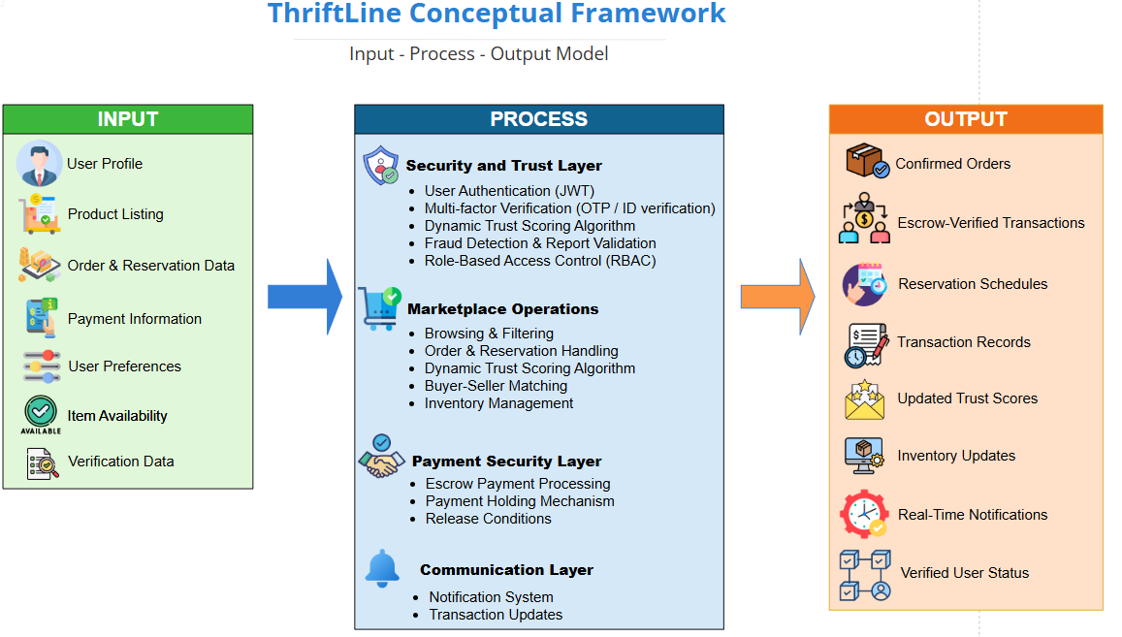
The conceptual framework of ThriftLine follows the Input–Process–Output (IPO) model, illustrating how raw data is transformed through the system's core logic into actionable delivery outcomes.

Figure 3. Conceptual Framework (Appendix A)
2.3.1.1 Input
The INPUT layer consists of user-provided and system-generated data necessary for secure transactions within the platform. This includes buyer and seller profiles, product listings, order and reservation details, payment information, user preferences, item availability, and verification data such as email addresses, phone numbers, and identity documents used for user verification and trust assessment.
2.3.1.2 Process
The PROCESS layer encompasses the system's core functionalities and security mechanisms. It includes user authentication and authorization, multi-factor user verification, product browsing and filtering, order and reservation handling, buyer-seller matching, and inventory management. Additionally, the system implements a Dynamic Trust and Verification System that evaluates user credibility based on identity verification, transaction history, successful transactions, user ratings, and confirmed reports. The process layer also incorporates an escrow-based payment mechanism that temporarily holds payments until transaction conditions are fulfilled, along with fraud reporting, dispute management, and real-time notification generation to ensure secure and reliable transactions.
2.3.1.3 Output
The OUTPUT layer produces meaningful and organized results, including confirmed orders, escrow-verified transactions, reservation schedules, transaction records, updated inventory status, trust scores, verified user statuses, and real-time notifications. These outputs enable buyers and sellers to conduct transactions more securely, improve accountability among users, and enhance trust and confidence within the online thrift marketplace.

Weighted Sum Model-based Dynamic Trust and Verification Framework
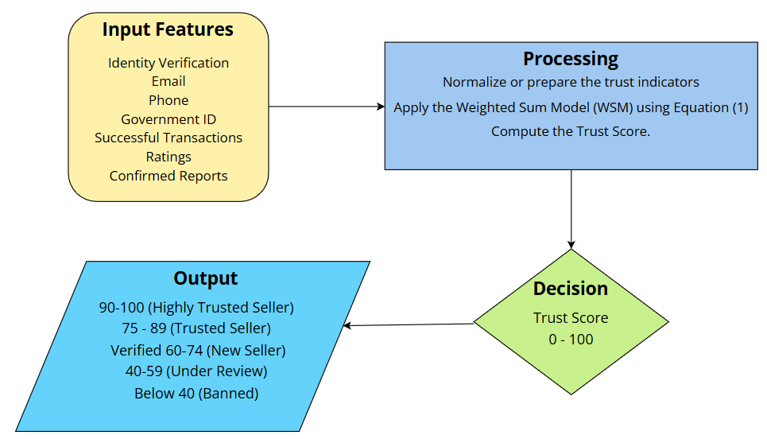
The proposed study integrates a Weighted Sum Model (WSM)-based Dynamic Trust Scoring System as the core trust evaluation mechanism of the ThriftLine mobile application. The Weighted Sum Model (WSM) is a Multi-Criteria Decision-Making (MCDM) algorithm that evaluates alternatives by assigning corresponding weights to multiple evaluation criteria and aggregating them into a single numerical score. This approach enables the simultaneous consideration of several trust indicators, making it suitable for applications that require objective and transparent decision-making. A related study [13] demonstrated that combining multiple weighted trust attributes provides a more comprehensive and reliable trust evaluation than relying on a single trust indicator. Their proposed weighted trust aggregation mechanism improved the assessment of honesty and reliability in the Internet of Vehicles by integrating multiple trust-related parameters into a unified trust score. Inspired by this approach, the proposed study adapts the Weighted Sum Model to evaluate seller credibility within a centralized online thrift marketplace. In the proposed ThriftLine system, seller trustworthiness is assessed using multiple trust-related criteria, including identity verification, successful transaction history, buyer ratings, and confirmed administrative reports. Rather than relying solely on user ratings or identity verification, the proposed trust mechanism combines these criteria into a unified trust score that reflects the seller's overall credibility. The computed trust score serves as the basis for assigning seller credibility classifications that are displayed within the marketplace and used by administrators for monitoring seller activities.

Figure 4. IPO model with trust score
The proposed Dynamic Trust Scoring System evaluates seller credibility using four trust-related criteria: Identity Verification (IV), Successful Transaction Score (ST), User Rating Score (UR), and Confirmed Report Penalty (CR). These indicators were selected based on established trust and reputation mechanisms used in e-commerce platforms. Identity Verification represents the authenticity of the seller, while Successful Transaction Score reflects the seller's demonstrated transactional reliability. User Rating Score represents customer-generated reputation based on completed transactions, while Confirmed Report Penalty accounts for verified negative behavior or marketplace policy violations. The use of multiple indicators is consistent with recent e-commerce reputation research, which demonstrates that user reputation can be assessed through combinations of authentication, transaction history, past reputation, and user behavior rather than through a single factor [14] Accordingly, these indicators were adapted to the specific requirements of the ThriftLine marketplace to provide a multi-dimensional assessment of seller credibility.

Identity Verification (IV)
Identity Verification confirms the authenticity of every seller before they are permitted to conduct selling activities on the platform. As part of the seller registration process, users are required to complete the verification procedure by submitting a government-issued identification card, verifying their email address through a One-Time Password (OTP), verifying their mobile number through SMS OTP, and completing a facial verification process for identity matching. These verification requirements ensure that each seller is linked to a legitimate identity, reducing the likelihood of anonymous or fraudulent accounts participating in marketplace transactions. Previous research established that identity binding and multi-factor authentication are critical baseline requirements for mitigating impersonation, Sybil account creation, and whitewashing attacks in e-commerce environments [15].

Successful Transaction Score (ST)
The Successful Transaction Score represents the seller's transaction reliability based on completed and successfully fulfilled orders within the platform. A transaction is considered successful only after the buyer confirms receipt of the item and the transaction reaches completion according to the system's transaction workflow. This criterion is supported by research demonstrating that users' transactional history can serve as a basis for dynamically estimating reputation in an online peer-to-peer platform [16]. The study incorporates accumulated transaction-related activities into reputation assessment and found that historical negative outcomes, such as previous defaults, adversely affect reputation. The study further emphasizes that reputation evolves from users' historical actions and transactions over time. Accordingly, ThriftLine adapts this transaction-based reputation principle by using successfully completed orders as positive evidence of seller reliability. As sellers accumulate verified successful transactions, their ST score increases to reflect demonstrated transactional reliability.

User Rating Score (UR)
The User Rating Score represents customer satisfaction and feedback based on post-transaction evaluations submitted by verified buyers. Previous research demonstrated that online customer ratings have a significant positive influence on consumer purchase decisions and trust in e-commerce platforms [17]. The study explains that post-purchase customer ratings serve as social proof and key informational cues that reduce transaction uncertainty, signal product and service quality, and reinforce buyer confidence. Accordingly, ThriftLine adapts this feedback-driven trust principle by incorporating verified buyer ratings as a core component of the proposed WSM-based trust model. To preserve rating integrity and prevent fabricated reviews, only buyers who have completed a verified purchase are permitted to submit evaluations. As sellers consistently receive high ratings from completed transactions, their UR score increases to reflect demonstrated customer satisfaction and service reliability.

Confirmed Report Penalty (CR)
The Confirmed Report Penalty reflects verified policy violations and compliance breaches committed by a seller during marketplace transactions. Previous research demonstrated that incorporating verified violation data, such as official administrative penalties, confirmed dispute rulings, and legal compliance records, provides reliable penalty signals for identifying untrustworthy e-commerce sellers [18]. The study emphasizes that while general user reviews can be subjective or susceptible to strategic manipulation, confirmed administrative findings and verified dispute records provide stronger evidence of seller non-compliance and trust risks. Accordingly, ThriftLine adapts this principle by penalizing seller credibility only after submitted reports undergo administrative investigation and confirmation. This design prevents unverified or bad-faith buyer complaints from unfairly suppressing an honest seller's score, while ensuring that confirmed violations are incorporated into the seller's dynamic trust evaluation.

To objectively evaluate seller credibility, each trust criterion is assigned a numerical score ranging from 0 to 100. The assigned score reflects the seller's performance for a specific criterion and serves as the input to the Weighted Sum Model. The scoring rubrics were designed to ensure consistency and transparency in the computation of the overall trust score.

Table 12. Identity Verification
Verification Requirement | Score
Government ID Verified | 25
Email Verified | 25
Phone Verified | 25
Face Verification Passed | 25
Maximum Score | 100

Sellers must complete all four verification requirements before they are permitted to publish products. The total Identity Verification Score is obtained by summing the completed verification requirements.

Table 13. Successful Transactions
Completed Transactions | Score
0 | 0
1-10 | 20
11-20 | 40
21-30 | 60
31-50 | 80
Above 50 | 100

The Successful Transaction Score increases as sellers complete more successful transactions. Only transactions that have been fully completed and confirmed by both buyer and seller are counted. Transactions that are cancelled, refunded, or disputed are excluded.

Table 14. User Ratings
Average Rating | Score
5.0 | 100
4.5-4.9 | 90
4.0-4.4 | 80
3.5-3.9 | 70
3.0-3.4 | 60
Below 3.0 | 40

Only buyers with completed transactions can submit ratings. The system continuously updates the seller's User Rating Score whenever a new verified rating is received.

Table 15. Confirmed Reports
Confirmed Reports | Score
0 | 100
1 | 80
2 | 60
3 | 40
4 | 20
5 or more | 0

Reports affect the seller's trust score only after they have been reviewed and confirmed by the administrator. Unverified or malicious reports do not contribute to the penalty score.
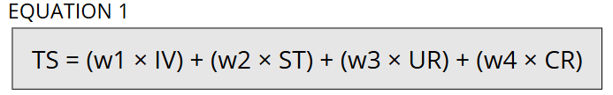
Figure 5. Trust Score Equation
Where TS represents the overall Trust Score; IV denotes the Identity Verification Score (0–100); ST refers to the Successful Transaction Score (0–100); UR represents the User Rating Score (0–100); CR denotes the Confirmed Report Penalty (0–100); and w₁, w₂, w₃, and w₄ represent the corresponding weights assigned to each trust indicator.
The weights assigned to the trust indicators are 0.40 for identity verification (w₁), 0.30 for successful transactions (w₂), 0.20 for user ratings (w₃), and 0.10 for confirmed reports (w₄). These weights are used in Equation (1) to calculate the overall Trust Score of each seller.

To illustrate the computation, consider a seller with the following scores:

Table 16. Sample Trust Score Computation
Criterion | Score | Weight | Weighted Score
Identity Verification | 100 | 0.40 | 40
Successful Transaction | 20 | 0.30 | 6
User Rating | 90 | .20 | 18
Confirmed Reports | 80 | 0.10 | 8
Total Trust Score |  |  | 72

Based on this computation, the seller obtains an overall Trust Score of 72. The computed Trust Score is dynamically recalculated whenever there are changes to the seller's verification status, completed transactions, buyer ratings, or compliance record. This ensures that the displayed Trust Score continuously reflects the seller's most recent performance and marketplace behavior.
After computing the seller's overall Trust Score using the Weighted Sum Model, the system classifies the seller into predefined trust levels. These classifications provide buyers with a quick and transparent indication of a seller's credibility while assisting administrators in monitoring seller performance. As sellers complete more successful transactions, receive positive buyer ratings, maintain compliance with marketplace policies, and retain their verified status, their Trust Score is dynamically updated and their trust classification is adjusted accordingly.

Table 17. Seller Trust Classification
Trust Score | Trust Classification
90-100 | Highly Trusted Seller
75-89 | Trusted Seller
60-74 | New Seller
40-59 | Under Review
Below 40 | Banned
The seller's trust classification is displayed on the seller's profile and product listings to provide buyers with an additional basis for evaluating seller credibility before initiating a transaction. The Trust Score and corresponding classification are automatically recalculated whenever changes occur in the seller's trust evaluation criteria, ensuring that the displayed credibility level accurately reflects the seller's current marketplace behavior.

Table 18. Scam Prevention Mechanisms
Common Scam Scenario | Proposed System Mechanism
Fake seller accounts | Seller Verification Process
Anonymous or duplicate accounts | Device and IP Address Monitoring
Seller receives payment but does not ship the item | Escrow-Based Payment System
Fake buyer or fake product reviews | Verified Purchase Rating System
False scam reports | Administrative Report Validation
Repeated fraudulent behavior | Dynamic Trust Scoring System
Marketplace policy violations | Administrative Monitoring

The integration of these security mechanisms provides multiple layers of protection throughout the marketplace transaction lifecycle. Identity verification reduces the creation of fraudulent seller accounts, escrow-based payments protect buyers from payment-related scams, verified purchase ratings preserve the integrity of user feedback, and administrative validation prevents abuse of the reporting system. In addition, the Dynamic Trust Scoring System continuously reflects seller behavior, allowing buyers to evaluate seller credibility while enabling administrators to identify and manage potentially fraudulent accounts more effectively. By combining preventive, detective, and corrective security measures within a centralized marketplace platform, the proposed system aims to establish a safer and more transparent environment for online thrift transactions while reducing opportunities for fraudulent activities.
Since the proposed ThriftLine system handles sensitive user information, including personal identities, verification documents, contact details, and transaction records, appropriate security measures are incorporated to protect user data from unauthorized access, modification, and disclosure. User passwords are securely stored using password hashing techniques, while all communication between the mobile application and the server is protected through encrypted HTTPS connections. Government-issued identification cards and facial verification images submitted during the verification process are securely stored and are accessible only to authorized administrators for identity verification purposes. Furthermore, the system implements role-based access control (RBAC) to ensure that users can only access information relevant to their assigned roles. To further enhance account security, the system records device and IP address information to assist in detecting suspicious login attempts and fraudulent activities. In addition, payment transactions are processed through trusted third-party payment providers, ensuring that sensitive financial information is not directly stored within the application. These security measures are incorporated to safeguard user information, promote secure online transactions, and support the principles of the Data Privacy Act of 2012 (Republic Act No. 10173) by implementing appropriate technical and organizational measures for protecting personal data.
The effectiveness of the proposed Weighted Sum Model-based Dynamic Trust Scoring System will be evaluated through functional testing and user evaluation. Functional testing will verify that the system accurately computes Trust Scores based on the defined trust criteria, assigned weights, and trust classification levels. Following system validation, potential users will evaluate the completed application using an evaluation instrument based on the ISO/IEC 25010 System and Software Quality Model, with emphasis on Security, Functional Suitability, and Usability. In addition, respondents will assess whether the Trust Score, trust classifications, and verification features help them identify credible sellers, increase their confidence in conducting transactions, and contribute to a safer online marketplace. The evaluation results will be analyzed to determine whether the proposed trust mechanism effectively improves users' trust and confidence in the ThriftLine marketplace.

Data Models
Data models provide a structured representation of the system's functional processes, data organization, and overall architecture. They serve as blueprints that describe how users interact with the system, how data is stored and related, how information flows through different system components, and how the user interface supports these processes.

2.3.3.1 Use Case Diagram
ThriftLine System is a mobile thrift marketplace that enables buyers and sellers to conduct secure online transactions through product listings, communication tools, account verification, trust scoring, payment management, and dispute resolution mechanisms. Based on the proposed system, it integrates a Dynamic Trust and Verification System to improve transparency and reduce fraudulent activities. The use case diagram provides a high-level overview of the system's functional requirements by illustrating the interactions between the users and the major services offered by the application.
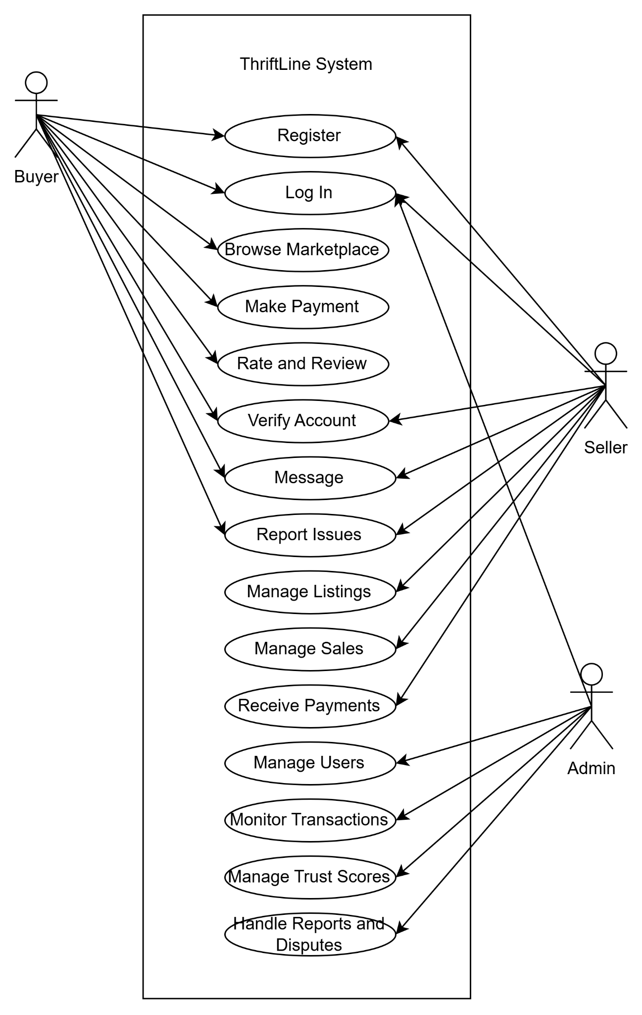
Figure 6. Thriftline Use Case Diagram

2.3.3.2 Entity Relationship Diagram
The Entity Relationship Diagram (ERD) illustrates the logical structure of the ThriftLine database by showing the entities, their attributes, and the relationships between them. It serves as the foundation for the database implementation, ensuring that user information, product listings, transactions, payments, messaging, trust scores, and other system data are stored efficiently while maintaining data integrity and consistency.
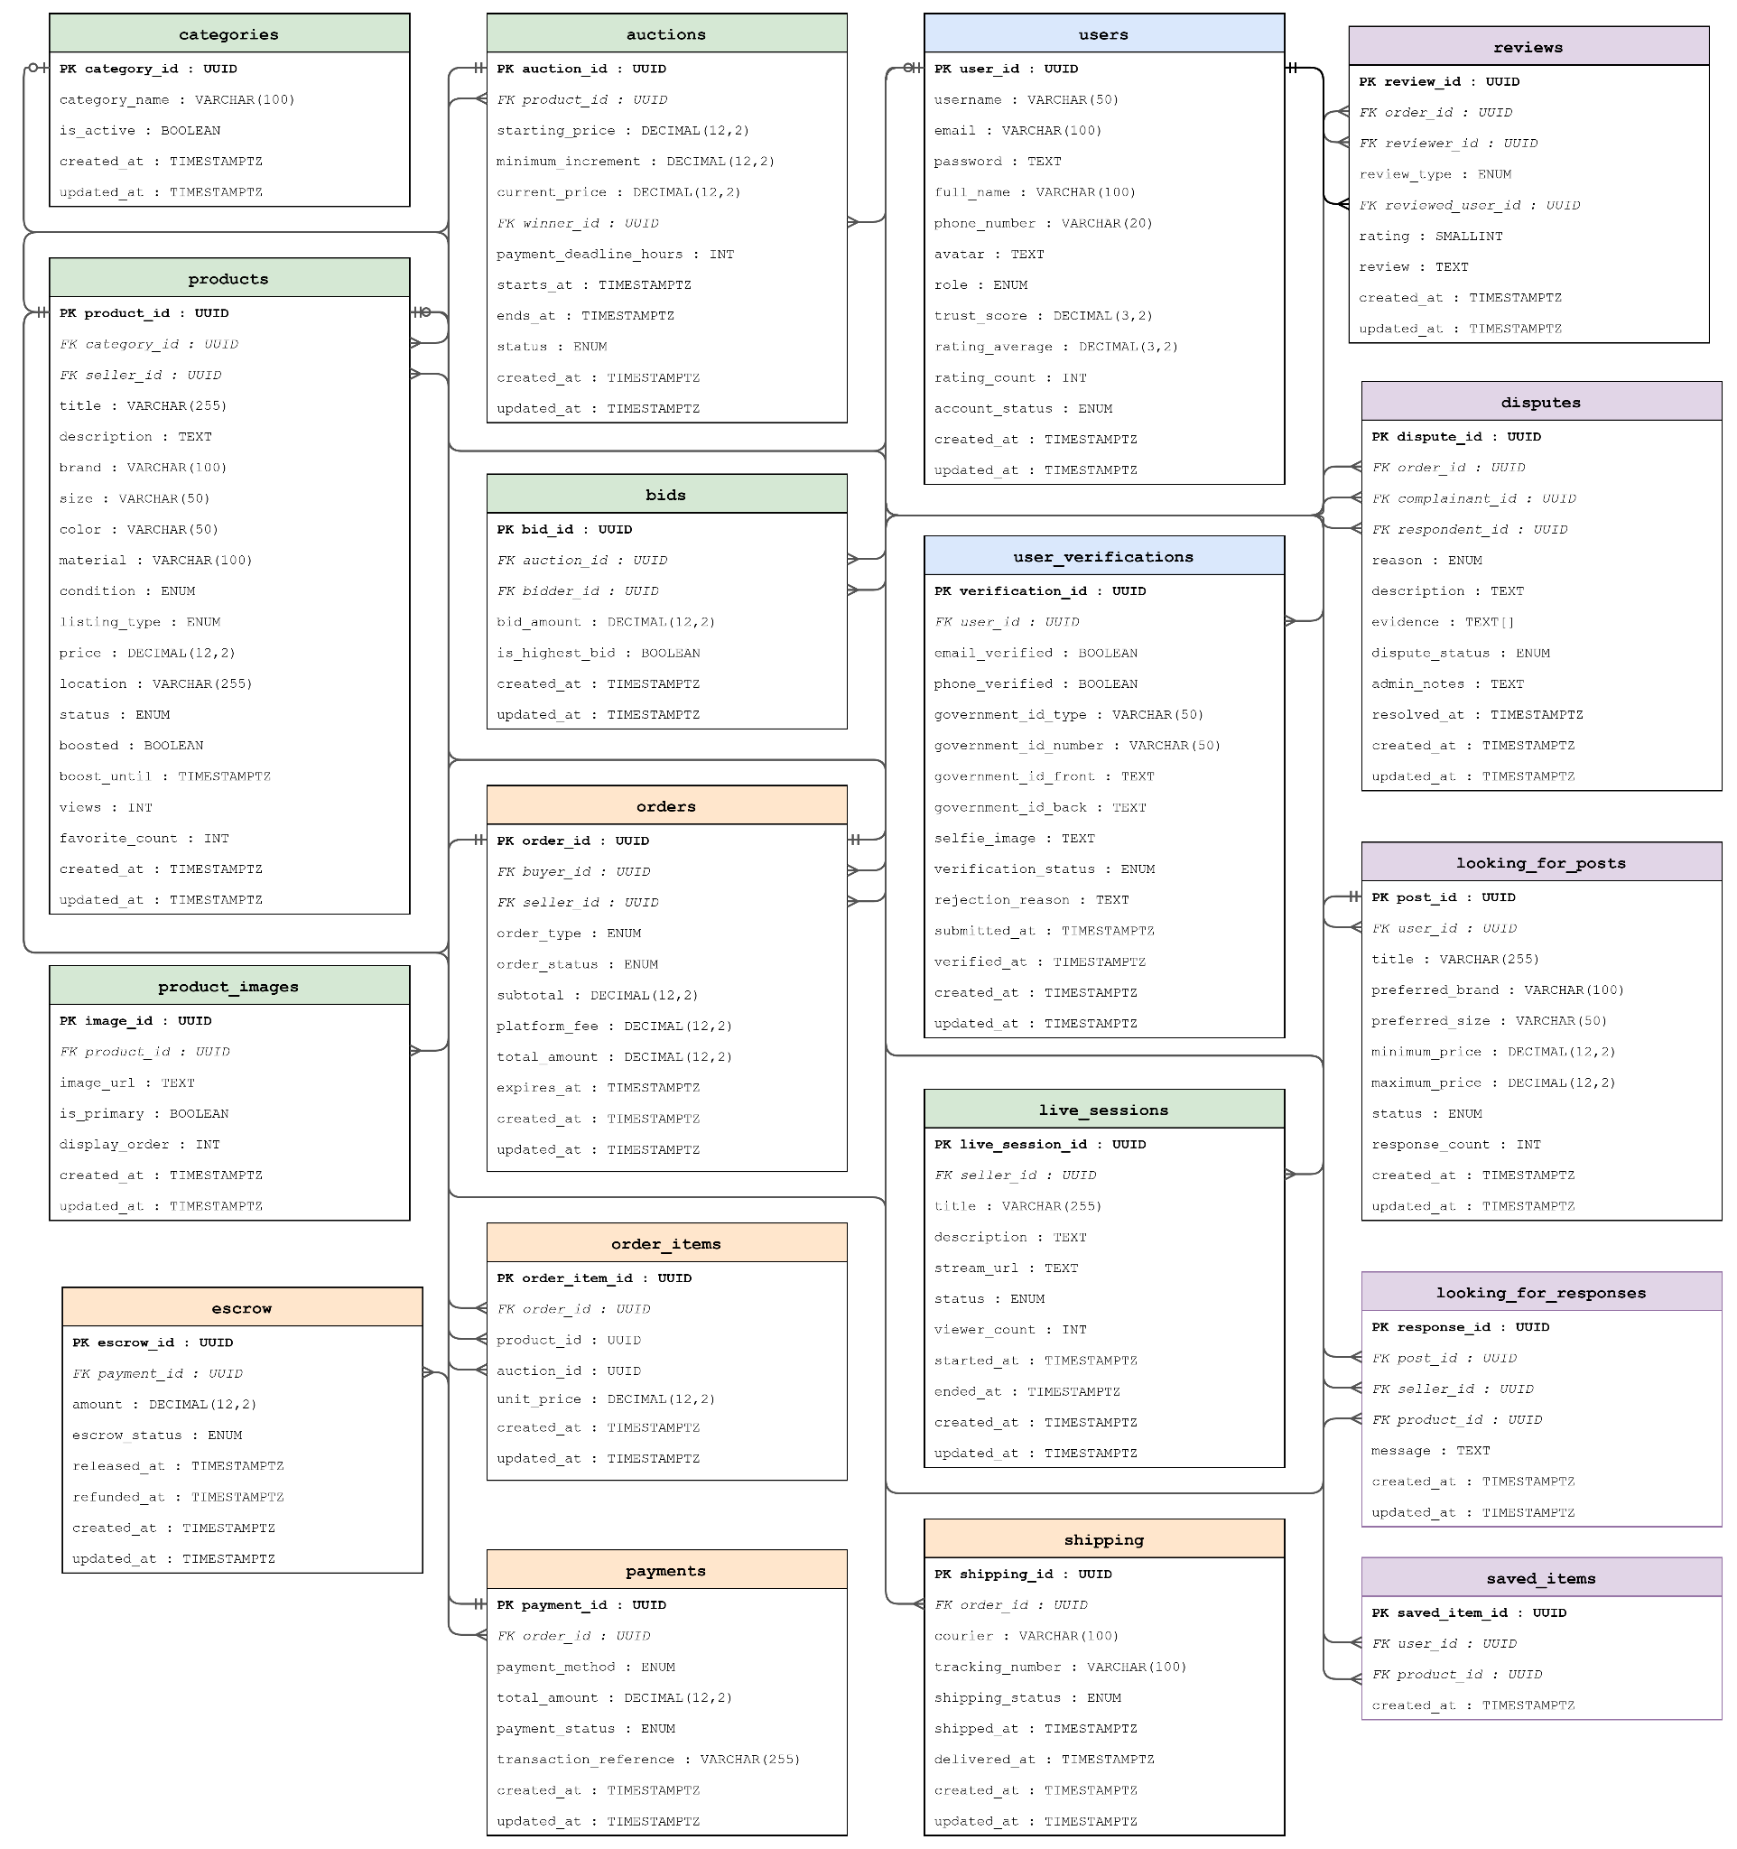
Figure 7. Entity Relationship Diagram (Appendix B)

2.3.3.3 Data Dictionary
The data dictionary describes the database tables used in the ThriftLine system and their corresponding fields. To improve readability, only the primary and most relevant fields of each table are presented in this section. The complete data dictionary, including all fields, data types, constraints, and relationships, is provided in Appendix C, serving as a reference for database implementation, maintenance, and future system enhancements.
This table stores all registered user accounts, encompassing buyers, sellers, and administrators, along with platform-computed trust scores and cached rating aggregates.

Table 19. Users Table
Column Name | Type | Constraint | Description
user_id | UUID | PK, NOT NULL, | Unique user identifier
email | VARCHAR(50) | NOT NULL | Users email
username | VARCHAR(50) | UNIQUE, NOT NULL | Public-facing username
role | ENUM | NOT NULL | User role
trust_score | DECIMAL(3,2) | NOT NULL | Platform trust score (0–5)
account_status | ENUM | DEFAULT 'active' | Current account status
This table serves as the master reference list of product categories used to classify and filter item listings across the platform.

Table 20. Categories Table
Column Name | Type | Constraint | Description
category_id | UUID | PK, NOT NULL, | Unique category identifier
category_name | VARCHAR(100) | UNIQUE, NOT NULL | Unique category identifier
is_active | BOOLEAN | DEFAULT TRUE | Visible to users on the platform
This table is designated for maintaining KYC (Know Your Customer) verification records per user, including submitted government identification details, biometric selfie references, and administrator approval status.

Table 21 Users Verification Table
Column Name | Type | Constraint | Description
verification_id | UUID | PK, NOT NULL, | Unique identifier for the verification record
user_id | UUID | FK → users(user_id), NOT NULL | References the user being verified
government_id_type | VARCHAR(50) | NOT NULL | Type of government ID submitted (e.g. PhilSys, Passport , SSS, TIN)
verification_status | ENUM | DEFAULT 'pending' | Current status of the verification request
submitted_at | TIMESTAMP | NULL | Submission Date
This table represents all item listings posted by sellers, supporting fixed-price, auction, and live-selling modalities, along with condition grading, pricing, and promotional boost metadata.

Table 22. Products Table
Column Name | Type | Constraint | Description
product_id | UUID | PK, NOT NULL | Unique identifier for the product listing
category_id | UUID | FK → categories(category_id), NULL | Category the product belongs to (optional)
seller_id | UUID | FK → users(user_id), NOT NULL | The seller who created the listing
title | VARCHAR(255) | NOT NULL | Title of the product listing
price | DECIMAL(12,2) | NOT NULL | Selling price in Philippine Peso (PHP)
listing_type | ENUM | NOT NULL | Listing method
status | ENUM | NOT NULL, DEFAULT 'active' | Current status of the listing

This table is responsible for defining the auction parameters for products listed under the auction modality, including opening price, minimum bid increment, scheduling window, and winner reference.

Table 23. Auctions Table
Column Name | Type | Constraint | Description
auction_id | UUID | PK, NOT NULL, DEFAULT | Unique identifier for the auction
product_id | UUID | FK → products(product_id), NOT NULL | The product being auctioned
starting_price | DECIMAL(12,2) | NOT NULL | Opening bid price in PHP
minimum_increment | DECIMAL(12,2) | NOT NULL | Minimum bid increment (PHP)
current_price | DECIMAL(12,2) | NOT NULL | Highest bid price
winner_id | UUID | FK → users(user_id), | Auction winner (set when ended)
status | ENUM | NOT NULL, | Current auction status

This table is used for associating one or more image URLs with a product listing, designating a primary cover image and enforcing a defined display order for the image gallery.

Table 24. Products Image Table
Column Name | Type | Constraint | Description
image_id | UUID | PK, NOT NULL, | Unique image identifier
product_id | UUID | FK → products(product_id), NOT NULL | The product this image belongs to
image_url | TEXT | NOT NULL | Image URL in Supabase Storage

This table records all individual bid submissions placed by users on active auctions, tracking bid amounts and flagging the current highest bid.

Table 25. Bidding Table
Column Name | Type | Constraint | Description
bid_id | UUID | PK, NOT NULL, | Unique identifier for the bid
auction_id | UUID | FK → auctions(auction_id), NOT NULL | The auction this bid is placed on
bidder_id | UUID | FK → users(user_id), NOT NULL | The user who placed the bid
bid_amount | DECIMAL(12,2) | NOT NULL | Bid amount
is_highest_bid | BOOLEAN | DEFAULT FALSE | Current leading bid
This table represents live-selling broadcast sessions hosted by sellers, including scheduling metadata, stream endpoint, operational status, and peak viewer count.

Table 26. Live Sessions Table
Column Name | Type | Constraint | Description
live_session_id | UUID | PK, NOT NULL, | Unique identifier for the live session
seller_id | UUID | FK → users(user_id), NOT NULL | The seller hosting the live session
title | VARCHAR(255) | NOT NULL | Title of the live session
status | ENUM | NOT NULL | Current state of the live session
This table is for capturing purchase transactions initiated by buyers across all selling modalities (direct, auction, or live), consolidating pricing, fees, and lifecycle status.

Table 27. Orders Table
Column Name | Type | Constraint | Description
order_id | UUID | PK, NOT NULL | Unique identifier for the order
buyer_id | UUID | FK → users(user_id)), NOT NULL | The buyer who placed the order
seller_id | UUID | FK → users(user_id)), NOT NULL | The seller fulfilling the order
auction_id | UUID | FK → auctions(auction_id),), NOT NULL | Linked auction record
order_status | ENUM | NOT NULL, DEFAULT 'pending' | Current status of the order lifecycle
platform_fee | DECIMAL(12,2) | NOT NULL | Platform commission fee
total_amount | DECIMAL(12,2) | NOT NULL | Total charged to buyer
This table stores the individual product line items belonging to an order, enabling a single order to contain multiple products from the same seller.

Table 28. Orders Item Table
Column Name | Type | Constraint | Description
order_item_id | UUID | PK, NOT NULL | Unique line item identifier
order_id | UUID | FK → orders(order_id), NOT NULL | Parent order this item belongs to
product_id | UUID | FK → products(product_id), NOT NULL | Product being purchased
This table represents products bookmarked by users for future reference, serving as the source of truth for the cached favorite count maintained on the products table.

Table 29. Saved Items Table
Column Name | Type | Constraint | Description
saved_item_id | UUID | PK, NOT NULL, | Unique identifier for the saved item record
user_id | UUID | FK → users(user_id), NOT NULL | The user who saved the item
product_id | UUID | FK → products(product_id) | The product that was saved/favorited
This table stores payment transactions associated with each order, documenting the payment method, total amount, processing status, and external gateway reference.

Table 30. Payments Table
Column Name | Type | Constraint | Description
payment_id | UUID | PK, NOT NULL, | Unique payment identifier
order_id | UUID | FK → orders(order_id), | Order this payment belongs to
payment_method | ENUM | NOT NULL | Payment method chosen by the buyer
total_amount | DECIMAL(12,2) | NOT NULL | Total amount paid in PHP
payment_status | ENUM | NOT NULL, DEFAULT 'pending' | Current status of the payment transaction

This table is used for storing courier assignment and parcel tracking information per order, monitoring shipment progress from dispatch through delivery confirmation.

Table 31. Shipping Table
Column Name | Type | Constraint | Description
shipping_id | UUID | PK, NOT NULL, ) | Unique identifier for the shipping record
order_id | UUID | FK → orders(order_id), NOT NULL | The order being shipped
courier | VARCHAR(100) | NOT NULL | Courier service used (e.g. J&T Express, Shopee Express)
tracking_number | VARCHAR(100) | NULL | Courier tracking number
shipping_status | ENUM | NOT NULL, DEFAULT 'pending' | Current delivery status of the shipment

This table is designed for tracking the holding and conditional release of buyer funds, ensuring payment is disbursed to the seller only upon confirmed delivery.

Table 32Escrow Table
Column Name | Type | Constraint | Description
escrow_id | UUID | PK, NOT NULL | Unique identifier escrow record
payment_id | UUID | FK → payments(payment_id) | The payment held in escrow
amount | DECIMAL(12,2) | NOT NULL | Amount held in escrow in PHP
escrow_status | ENUM | NOT NULL, DEFAULT 'holding' | Current state of the escrow funds
This table is for recording buyer-initiated want ads specifying sought-after items, with optional preferences for brand, size, and acceptable price range.

Table 33. Looking for Post Table
Column Name | Type | Constraint | Description
post_id | UUID | PK, NOT NULL, | Unique identifier for the looking-for post
user_id | UUID | FK → users(user_id), NOT NULL | The buyer who created the post
seller_id | UUID | FK → users(user_id) | The seller submitting the response
title | VARCHAR(255) | NOT NULL | Short description of what the buyer is looking for
status | ENUM | NOT NULL, DEFAULT 'open' | Whether the post is still accepting seller responses

This table stores seller replies to buyer want ads, optionally referencing an existing product listing as a matching offer.

Table 34. Looking for Response Table
Column Name | Type | Constraint | Description
response_id | UUID | PK, NOT NULL, | Unique response identifier
post_id | UUID | FK → looking_for_posts(post_id) | Looking-for post being responded to
message | TEXT | NOT NULL | Seller's response message

This table is designated for capturing post-transaction ratings and written evaluations exchanged between buyers and sellers upon order completion.

Table 35. Reviews Table
Column Name | Type | Constraint | Description
review_id | UUID | PK, NOT NULL, | Unique identifier for the review
order_id | UUID | FK → orders(order_id), NOT NULL | The completed order this review is based on
reviewer_id | UUID | FK → users(user_id), NOT NULL | The user leaving the review
reviewed_user_id | UUID | FK → users(user_id), NOT NULL | The user receiving the review
rating |  | NOT NULL, | Numeric star rating (1-5_

2.3.3.4 Architecture Design
The architecture design presents the overall structure of the ThriftLine system, illustrating how the mobile application, backend services, database, and external services interact to process requests and manage data. It demonstrates the flow of information between system components and provides a clear overview of the platform's technical infrastructure.
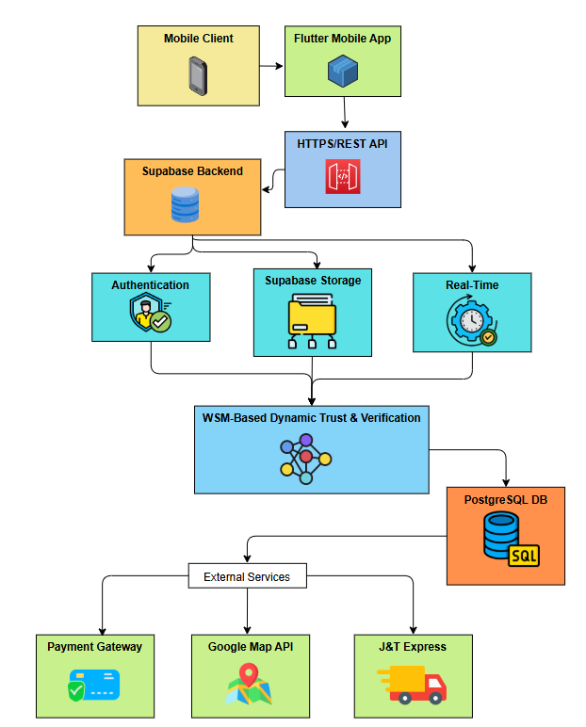

Figure 8. Thriftline System Architecture Diagram
2.3.3.5 Sample Prototypes
This prototype displays the buyer's home screen for browsing and discovering thrift items. It provides quick access to the platform's main shopping features.
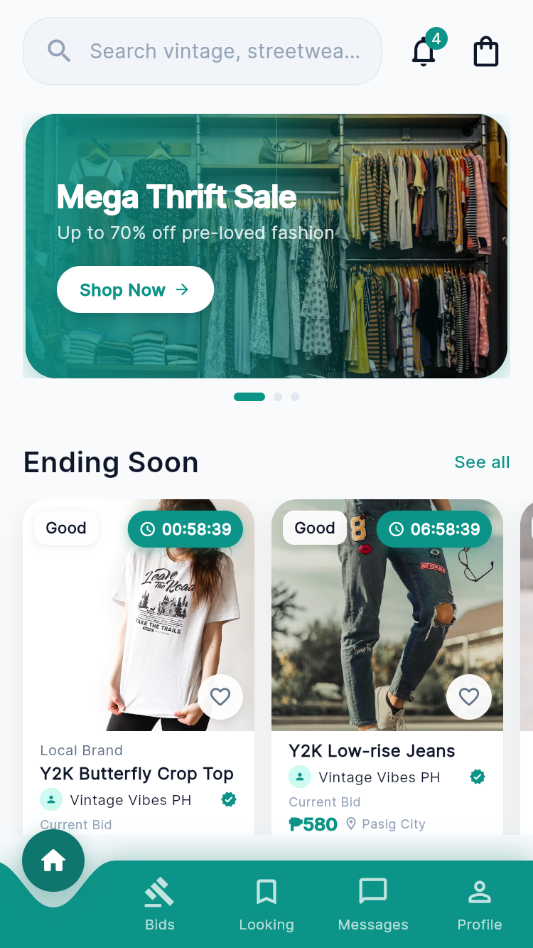
Figure 9. Buyer Home Screen
This prototype presents the product information and real-time bidding feature for buyers.
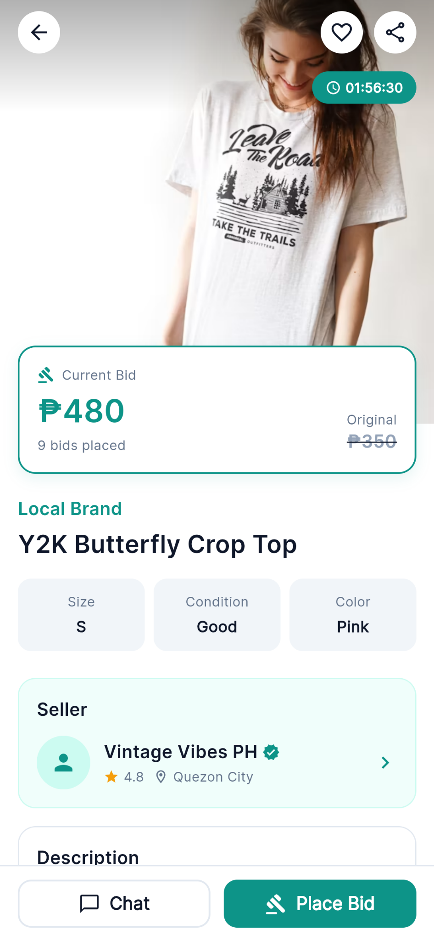

Figure 10. Product Details with Real-Time Bidding
This prototype shows the seller profile interface, displaying the seller's trust badge, verification status, ratings, and profile information to help buyers assess seller credibility.


Figure 11. Seller Profile Interface
This prototype shows the report review interface, where users can verify the report details and attached evidence before submitting the report.
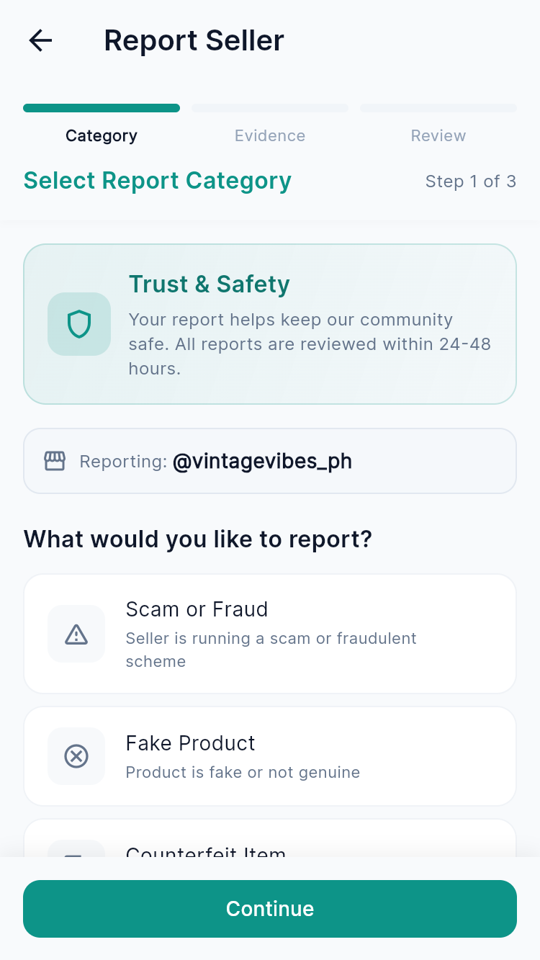
Figure 12. Report Category Selection
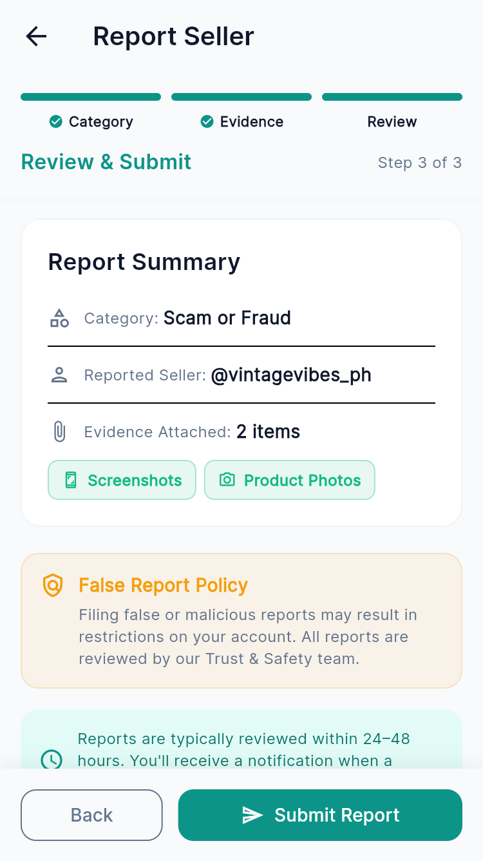
Figure 13. Report Review and Submission
This prototype displays the user's active, won, and lost bids. It allows buyers to monitor their bidding status in one place.
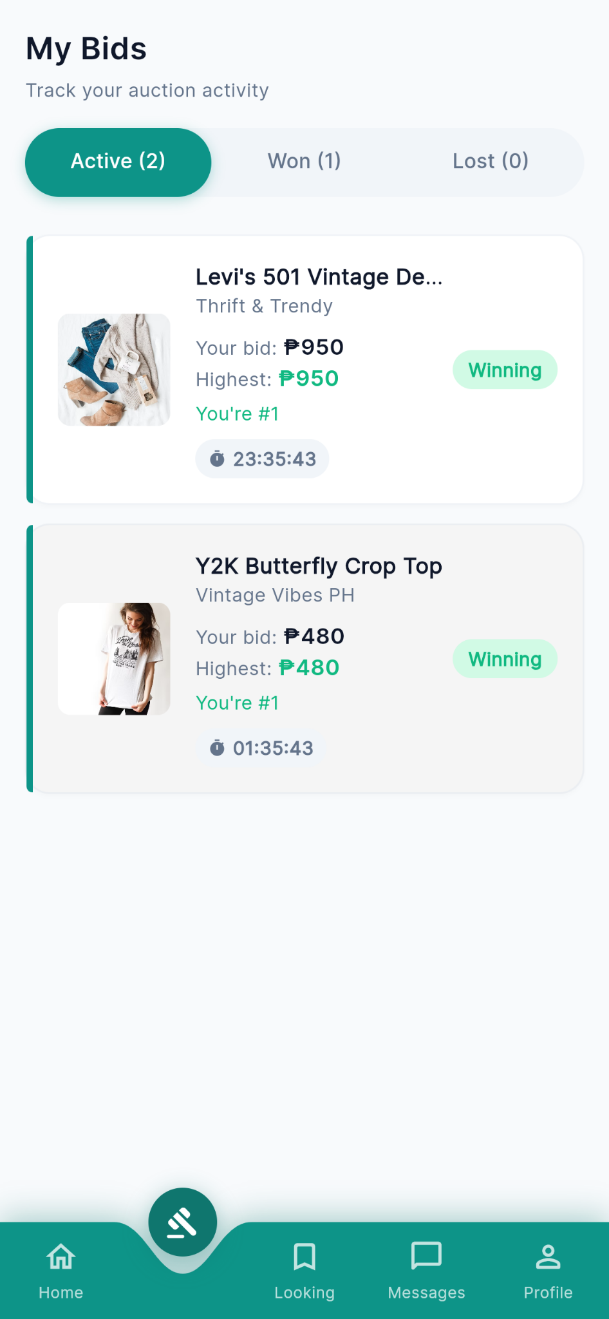
Figure 14. My Bids Screen
This prototype displays Looking for specific thrift items. It enables users to browse and post item requests within the platform.
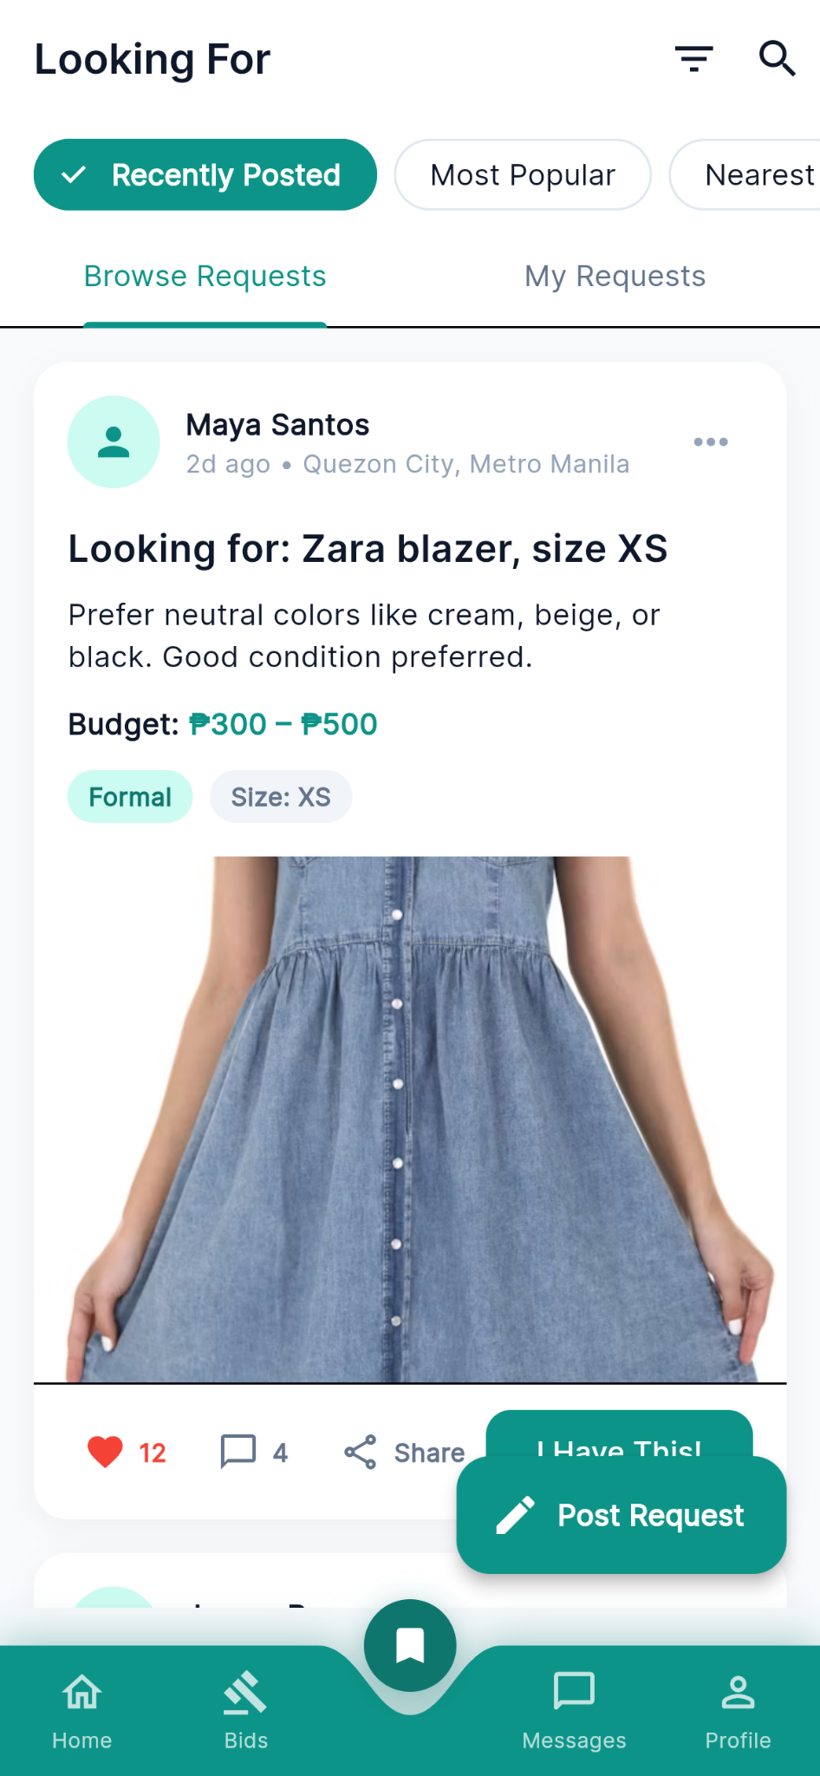
Figure 15. Request Marketplace
This prototype displays conversations between buyers and sellers. It enables users to communicate directly within the application.

Figure 16. Messages
This prototype shows the process of applying for seller verification and tracking the verification status after submitting the required store information and verification documents.
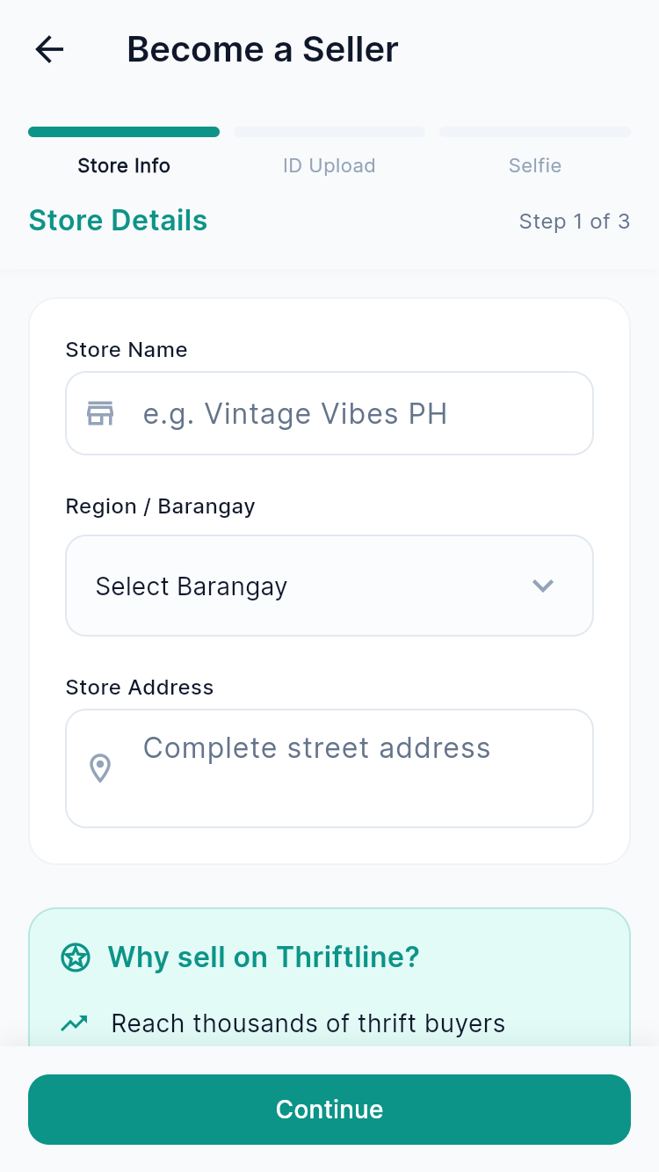
Figure 17. Seller Verification Application
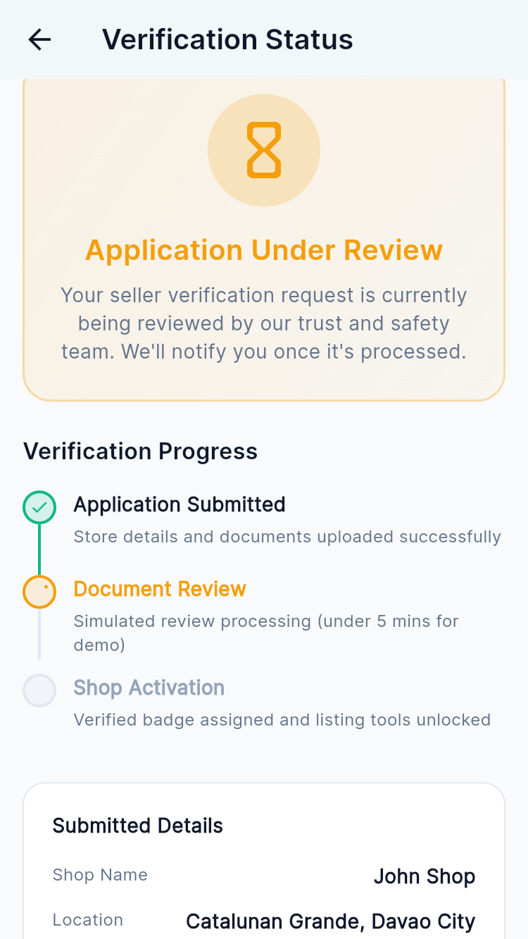
Figure 18. Seller Verification Status
This prototype displays the seller dashboard for managing listings, orders, sales, and business performance. It provides quick access to the seller's key features and analytics.
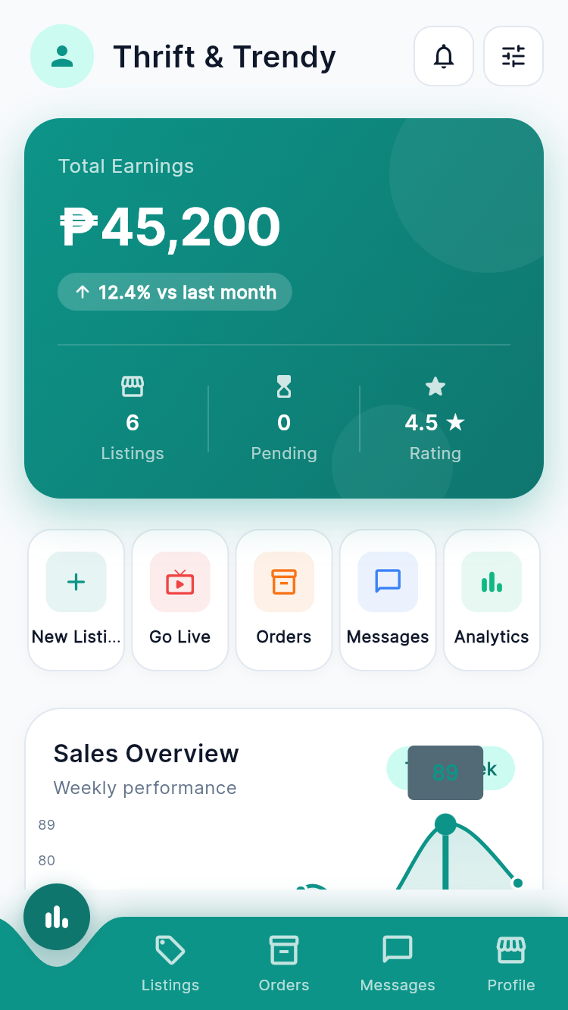
Figure 19. Seller Dashboard
This prototype displays the seller's active and draft product listings. It allows sellers to manage and monitor their posted items.

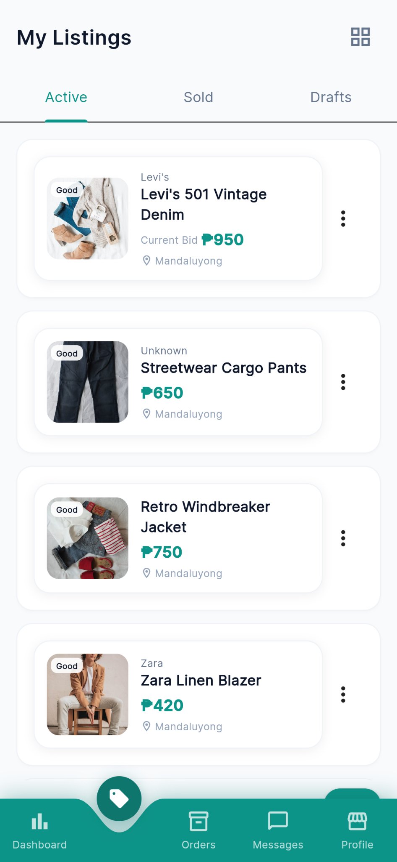
Figure 20. My Listings
This prototype displays the seller's orders by status. It allows sellers to monitor and manage customer orders.
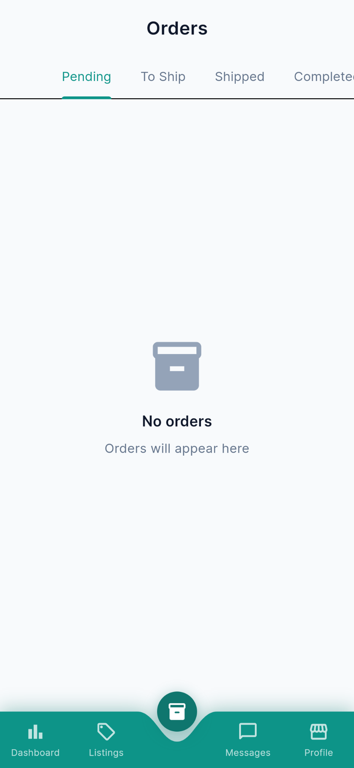
Figure 21. Orders
This prototype displays the seller's profile and active product listings. It allows sellers to manage their shop information and showcase their products.
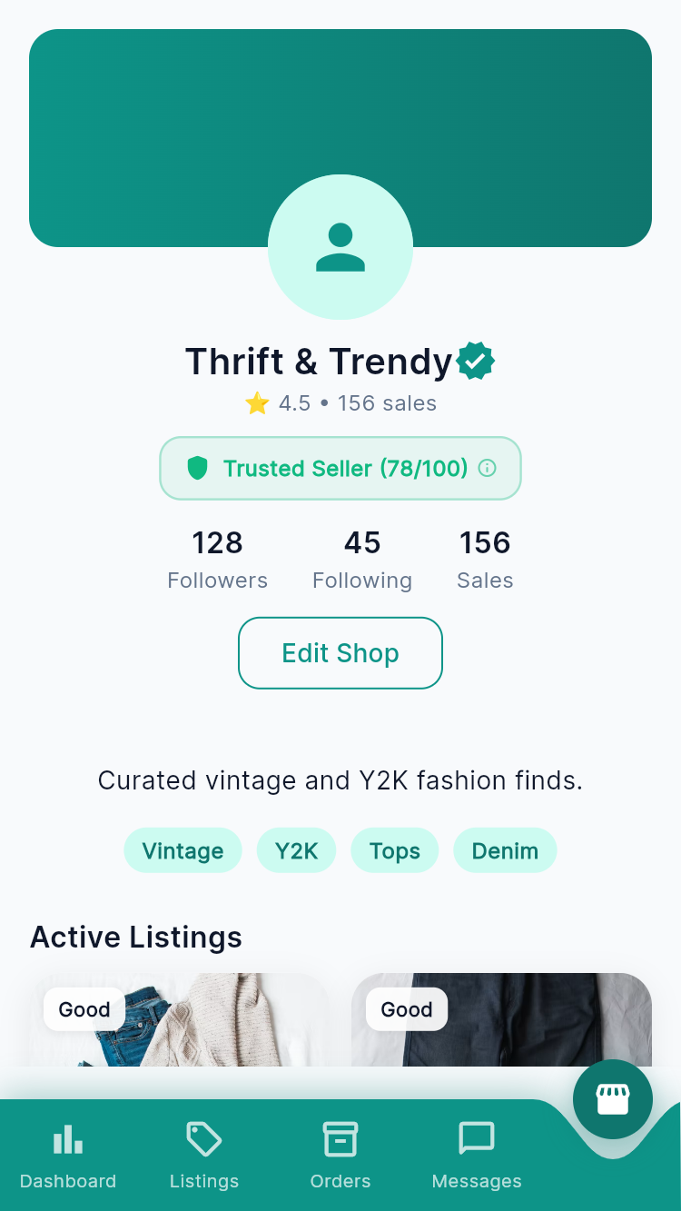
Figure 22. Seller Profile

REFERENCES
- Carousell, “How to Deal Safely on Carousell.” [Online]. Available: https://support.carousell.com/hc/en-us/articles/115009696128-How-to-deal-safely-on-Carousell.
- R. A. C. Cabañero, “Tiffany: Ukay-Ukay Online Shop,” International Journal of Advanced Research in Science, Communication and Technology (IJARSCT), vol. 3, no. 2, pp. 722–729, Jul. 2023, doi: 10.48175/IJARSCT-12301.
- S. Handoyo, “Purchasing in the Digital Age: A Meta-Analytical Perspective on Trust, Risk, Security, and e-WOM in E-Commerce,” Heliyon, vol. 10, Art. no. e29714, 2024, doi: 10.1016/j.heliyon.2024.e29714.
- “Strategy To Enhance Consumer Trust in Online Auctions Through Social Media,” International Journal of Environmental Sciences, 2025, doi: 10.64252/yz8zes16.
- S. Ambag, R. Bernarte, and A. Bautista, “Selected Filipino Faculty Members' Online Shopping Experience in Manila's Online Marketplace,” Diversitas Journal, vol. 9, no. 1, 2024, doi: 10.48017/dj.v9i1.2684.
- V. G. Ocampo, R. Santos, R. Campo, L. G. Ocampo, and N. B. Capistrano, “Examining the Correlation Between Consumer Experiences with Deceptive Advertising and Perceived Platform Credibility and Purchase Intention in Online Shopping: The Case of the Philippines,” Journal of Information Systems Engineering and Management, vol. 10, no. 4, 2025, doi: 10.52783/jisem.v10i4.9604.
- X. Weng, D. Pan, and Y. Jin, “An Adaptive Distributed Consumer Trust Model for Social Commerce,” Applied Artificial Intelligence, vol. 38, no. 1, 2024, doi: 10.1080/08839514.2024.2385857.
- Z. Zhang, H. Yin, S. X. Rao, et al., “Identifying E-Commerce Fraud Through User Behavior Data: Observations and Insights,” Data Science and Engineering, vol. 10, pp. 24–39, 2025, doi: 10.1007/s41019-024-00275-6.
- R. Jiao, W. Przepiorka, and V. Buskens, “Reputation Effects in Peer-to-Peer Online Markets: A Meta-Analysis,” Social Science Research, vol. 95, Art. no. 102522, 2021, doi: 10.1016/j.ssresearch.2020.102522.

- R. H. Pereira, M. Gonçalves, and M. A. G. Magalhães, “Reputation Systems: A Framework for Attacks and Frauds Classification,” Journal of Information Systems Engineering and Management, 2023, doi: 10.55267/iadt.07.12830.
- F. Malak, J. Ferreira, R. P. de Queiroz Falcão, and C. Giovannini, “Seller Reputation Within the B2C e-Marketplace and Impacts on Purchase Intention,” Latin American Business Review, vol. 22, no. 3, pp. 287–307, 2021, doi: 10.1080/10978526.2021.1893182.
- N. Peña-García, M. Losada-Otálora, D. P. Auza, and M. P. Cruz, “Reviews, Trust, and Customer Experience in Online Marketplaces: The Case of Mercado Libre Colombia,” Frontiers in Communication, vol. 9, Art. no. 1460321, 2024, doi: 10.3389/fcomm.2024.1460321.
- S. A. Siddiqui, A. Mahmood, Q. Z. Sheng, H. Suzuki, and W. Ni, “Trust in Vehicles: Toward Context-Aware Trust and Attack Resistance for the Internet of Vehicles,” IEEE Transactions on Intelligent Transportation Systems, vol. 24, no. 9, pp. 9546–9560, 2023, doi: 10.1109/TITS.2023.3268766.
- K. S. Krishnan, R. C. Devi, C. Ananth, D. Easwaramoorthy, S. Agarwal, W. Pak, H. M. Rai, and S. Kant, “Blockchain-based two-level trustable reputation framework for e-commerce platform using smart contracts,” Scientific Reports, vol. 16, no. 1, Art. no. 14465, 2026, doi: 10.1038/s41598-026-44032-3.
- S. Qader Mohamedamin, “Aspects of digital identity in e-commerce,” OTS, vol. 4, no. 6, pp. 1–90, Jun. 2025, doi: 10.58840/cbj7ks45.
- J. Deng, H. Ghasemkhani, Y. Tan, and A. K. Tripathi, “Actions speak louder than words: Imputing users’ reputation from transaction history,” Production and Operations Management, vol. 32, pp. 1096–1111, 2023.
- B. Pamungkas and R. Dermawan, “The influence of seller reputation, online customer ratings, and free shipping programs on purchase decisions on Lazada e-commerce in Surabaya,” East Asian Journal of Multidisciplinary Research, 2025, doi: 10.55927/eajmr.v4i11.464.
- K. Liang, J. He, and P. Wu, “Trust evaluation method of e-commerce enterprises with high-involvement experience products,” Sustainability, vol. 14, no. 23, Art. no. 15562, 2022, doi: 10.3390/su142315562.

Appendices

Appendix A
Conceptual Framework

Appendix B
Entity Relationship Diagram

Appendix B
Complete Data Dictionary

Users Table
Column Name | Type | Constraint | Description
user_id | UUID | PK, NOT NULL, | Unique identifier for each user
username | VARCHAR(50) | UNIQUE, NOT NULL | Unique user identifier
email | VARCHAR(100) | UNIQUE, NOT NULL | Login email address
password | TEXT | NOT NULL | Bcrypt-hashed password
full_name | VARCHAR(100) | NOT NULL | User's full legal name
phone_number | VARCHAR(20) | NULL | Mobile number for OTP
avatar | TEXT | NULL | Profile picture URL st
role | ENUM | DEFAULT 'buyer' | User's role on the platform
trust_score | DECIMAL(3,2) | NOT NULL | Platform trust score (0–5)
rating_average | DECIMAL(3,2) | NULL | Cached avg. rating from reviews
rating_count | INT | NOT NULL, DEFAULT 0 | Cached total ratings received
account_status | ENUM | DEFAULT 'active' | Current account status
created_at | TIMESTAMPT | DEFAULT NOW() | Record creation timestamp
updated_at | TIMESTAMPT | DEFAULT NOW() | Last update timestamp

Categories Table
Column Name | Type | Constraint | Description
category_id | UUID | PK, NOT NULL, | Unique category identifier
category_name | VARCHAR(100) | UNIQUE, NOT NULL | Unique category identifier
is_active | BOOLEAN | DEFAULT TRUE | Visible to users on the platform
created_at | TIMESTAMPT | DEFAULT NOW() | Timestamp when the category was created
updated_at | TIMESTAMPT | DEFAULT NOW() | Timestamp of the last update

Users Verification Table
Column Name | Type | Constraint | Description
verification_id | UUID | PK, NOT NULL, | Unique identifier for the verification record
user_id | UUID | FK → users(user_id), NOT NULL | References the user being verified
email_verified | BOOLEAN | DEFAULT FALSE | Email verified via link/OTP
phone_verified | BOOLEAN | DEFAULT FALSE | Mobile number verified via OTP
government_id_type | VARCHAR(50) | NOT NULL | Type of government ID submitted (e.g. PhilSys, Passport , SSS, TIN)
government_id_number | VARCHAR(50) | NOT NULL | ID number (VARCHAR to preserve leading zeros)
government_id_front | TEXT | NULL | Front photo URL of submitted ID
government_id_back | TEXT | NULL | Back photo URL of submitted ID
selfie_image | TEXT | NULL | Selfie photo URL for liveness check
verification_status | ENUM | DEFAULT 'pending' | Current status of the verification request
rejection_reason | TEXT | NULL | Admin reason for rejection
submitted_at | TIMESTAMPT | NULL | When documents were submitted
verified_at | TIMESTAMPT | NULL | When an admin approved the verification
created_at | TIMESTAMPT | DEFAULT NOW() | Record creation timestamp
updated_at | TIMESTAMPT | DEFAULT NOW() | Timestamp of the last update

Auctions Table
Column Name | Type | Constraint | Description
auction_id | UUID | PK, NOT NULL, DEFAULT | Unique identifier for the auction
product_id | UUID | FK → products(product_id), NOT NULL | The product being auctioned
starting_price | DECIMAL(12,2) | NOT NULL | Opening bid price in PHP
minimum_increment | DECIMAL(12,2) | NOT NULL | Minimum bid increment (PHP)
current_price | DECIMAL(12,2) | NOT NULL | Highest bid price
winner_id | UUID | FK → users(user_id), | Auction winner (set when ended)
starts_at | TIMESTAMPT | NOT NULL | Scheduled start time
ends_at | TIMESTAMPT | NOT NULL | Scheduled end time
status | ENUM | NOT NULL, | Current auction status
created_at | TIMESTAMPT | DEFAULT NOW() | Record creation timestamp
updated_at | TIMESTAMPT | DEFAULT NOW() | Timestamp of the last update

Live Sessions Table
Column Name | Type | Constraint | Description
live_session_id | UUID | PK, NOT NULL, | Unique identifier for the live session
seller_id | UUID | FK → users(user_id), NOT NULL | The seller hosting the live session
title | VARCHAR(255) | NOT NULL | Title of the live session
description | TEXT | NULL | Optional description
stream_url | TEXT | NULL | LStream URL
status | ENUM | NOT NULL, DEFAULT 'scheduled' | Current state of the live session
viewer_count | INT | NOT NULL, DEFAULT 0 | Cached current or peak viewer count during the session
started_at | TIMESTAMPT | NULL | Actual timestamp when the stream went live

Products Table
Column Name | Type | Constraint | Description
product_id | UUID | PK, NOT NULL | Unique identifier for the product listing
category_id | UUID | FK → categories(category_id), NULL | Category the product belongs to (optional)
seller_id | UUID | FK → users(user_id), NOT NULL | The seller who created the listing
title | VARCHAR(255) | NOT NULL | Title of the product listing
description | TEXT | NULL | Detailed description of the product
brand | VARCHAR(100) | NULL | Brand name of the item (optional)
size | VARCHAR(50) | NULL | Size of the item (e.g. S, M, L, 32, Free Size)
color | VARCHAR(50) | NULL | Primary color of the item
material | VARCHAR(100) | NULL | Fabric or material of the item
condition | ENUM | NOT NULL | Physical condition of the item
listing_type | ENUM | NOT NULL | Selling method: fixed price, auction, or live session
price | DECIMAL(12,2) | NOT NULL | Selling price in Philippine Peso (PHP)
location | VARCHAR(255) | NOT NULL | Seller's location or preferred meetup area
status | ENUM | NOT NULL, DEFAULT 'active' | Current status of the listing
boosted | BOOLEAN | NOT NULL, DEFAULT FALSE | Whether the listing is currently boosted/promoted
boost_until | TIMESTAMPTZ | NULL | Expiry timestamp of the active boost (NULL if not boosted)
views | INT | NOT NULL, DEFAULT 0 | Number of views of the product
favorite_count | INT | NOT NULL, DEFAULT 0 | Cached save/favorite count; updated via trigger from saved_items

Products Image Table
Column Name | Type | Constraint | Description
image_id | UUID | PK, NOT NULL, | Unique image identifier
product_id | UUID | FK → products(product_id), NOT NULL | The product this image belongs to
image_url | TEXT | NOT NULL | Image URL in Supabase Storage
is_primary | BOOLEAN | NOT NULL, DEFAULT FALSE | Main/cover image of the listing
display_order | INT | NOT NULL, DEFAULT 0 | Gallery sort order (ascending)
created_at | TIMESTAMPT | DEFAULT NOW() | Record creation timestamp
updated_at | TIMESTAMPT | DEFAULT NOW() | Timestamp of the last update

Bidding Table
Column Name | Type | Constraint | Description
bid_id | UUID | PK, NOT NULL, | Unique identifier for the bid
auction_id | UUID | FK → auctions(auction_id), NOT NULL | The auction this bid is placed on
bidder_id | UUID | FK → users(user_id), NOT NULL | The user who placed the bid
bid_amount | DECIMAL(12,2) | NOT NULL | Bid amount
is_highest_bid | BOOLEAN | DEFAULT FALSE | Current leading bid
created_at | TIMESTAMPT | DEFAULT NOW() | Record creation timestamp
updated_at | TIMESTAMPT | DEFAULT NOW() | Timestamp of the last update

Saved Items Table
Column Name | Type | Constraint | Description
saved_item_id | UUID | PK, NOT NULL, | Unique identifier for the saved item record
user_id | UUID | FK → users(user_id), NOT NULL | The user who saved the item
product_id | UUID | FK → products(product_id), NOT NULL | The product that was saved/favorited

Orders Table
Column Name | Type | Constraint | Description
order_id | UUID | PK, NOT NULL | Unique identifier for the order
buyer_id | UUID | FK → users(user_id) | The buyer who placed the order
seller_id | UUID | FK → users(user_id) | The seller fulfilling the order
order_type | ENUM | NOT NULL | How the order was initiated
order_status | ENUM | NOT NULL, DEFAULT 'pending' | Current status of the order lifecycle
subtotal | DECIMAL(12,2) | NOT NULL | Item price before platform fee
platform_fee | DECIMAL(12,2) | NOT NULL | Platform commission fee
total_amount | DECIMAL(12,2) | NOT NULL | Total charged to buyer
expires_at | TIMESTAMPT | NULL | Payment deadline for auction orders

Orders Item Table
Column Name | Type | Constraint | Description
order_item_id | UUID | PK, NOT NULL | Unique line item identifier
order_id | UUID | FK → orders(order_id), NOT NULL | Parent order this item belongs to
product_id | UUID | FK → products(product_id), NOT NULL | Product being purchased
auction_id | UUID | FK → auctions(auction_id), | Linked auction record
unit_price | DECIMAL(12,2) | NOT NULL | Price snapshot at time of purchase

Payments Table
Column Name | Type | Constraint | Description
payment_id | UUID | PK, NOT NULL, | Unique payment identifier
order_id | UUID | FK → orders(order_id), | Order this payment belongs to
payment_method | ENUM | NOT NULL | Payment method chosen by the buyer
total_amount | DECIMAL(12,2) | NOT NULL | Total amount paid in PHP
payment_status | ENUM | NOT NULL, DEFAULT 'pending' | Current status of the payment transaction
transaction_reference | VARCHAR(255) | NULL | External gateway reference number

Shipping Table
Column Name | Type | Constraint | Description
shipping_id | UUID | PK, NOT NULL, ) | Unique identifier for the shipping record
order_id | UUID | FK → orders(order_id), NOT NULL | The order being shipped
courier | VARCHAR(100) | NOT NULL | Courier service used (e.g. J&T Express, LBC, Shopee Express)
tracking_number | VARCHAR(100) | NULL | Courier tracking number (provided after item is dropped off)
shipping_status | ENUM | NOT NULL, DEFAULT 'pending' | Current delivery status of the shipment
shipped_at | TIMESTAMPT | NULL | Timestamp when the seller handed the item to the courier
delivered_at | TIMESTAMPT | NULL | Timestamp when the item was confirmed delivered

Escrow Table
Column Name | Type | Constraint | Description
escrow_id | UUID | PK, NOT NULL | Unique identifier escrow record
payment_id | UUID | FK → payments(payment_id) | The payment held in escrow
amount | DECIMAL(12,2) | NOT NULL | Amount held in escrow in PHP
escrow_status | ENUM | NOT NULL, DEFAULT 'holding' | Current state of the escrow funds
released_at | TIMESTAMPT | NULL | Timestamp funds released to seller
refunded_at | TIMESTAMPT | NULL | Timestamp funds released to seller
.

Looking for Post Table
Column Name | Type | Constraint | Description
post_id | UUID | PK, NOT NULL, | Unique identifier for the looking-for post
user_id | UUID | FK → users(user_id), NOT NULL | The buyer who created the post
title | VARCHAR(255) | NOT NULL | Short description of what the buyer is looking for
preferred_brand | VARCHAR(100) | NULL | Preferred brand of the desired item (optional)
preferred_size | VARCHAR(50) | NULL | Preferred size of the desired item (optional)
minimum_price | DECIMAL(12,2) | NULL | Minimum acceptable offer price in PHP (optional)
maximum_price | DECIMAL(12,2) | NULL | Maximum budget the buyer is willing to pay in PHP (optional)
status | ENUM | NOT NULL, DEFAULT 'open' | Whether the post is still accepting seller responses
response_count | INT | NOT NULL, DEFAULT 0 | Cached count of seller responses

Looking for Response Table
Column Name | Type | Constraint | Description
response_id | UUID | PK, NOT NULL, | Unique response identifier
post_id | UUID | FK → looking_for_posts(post_id) | Looking-for post being responded to
seller_id | UUID | FK → users(user_id) | The seller submitting the response
product_id | UUID | FK → products(product_id) | Product being offered (optional)
message | TEXT | NOT NULL | Seller's response message
created_at | TIMESTAMPT | DEFAULT NOW() | Timestamp when the response was submitted
updated_at | TIMESTAMPT | DEFAULT NOW() | Timestamp of the last update

Reviews Table
Column Name | Type | Constraint | Description
review_id | UUID | PK, NOT NULL, | Unique identifier for the review
order_id | UUID | FK → orders(order_id), NOT NULL | The completed order this review is based on
reviewer_id | UUID | FK → users(user_id), NOT NULL | The user leaving the review
review_type | ENUM | NOT NULL | Direction of the review (who is reviewing whom)
reviewed_user_id | UUID | FK → users(user_id), NOT NULL | The user receiving the review
rating | SMALLINT | NOT NULL, CHECK (rating BETWEEN 1 AND 5) | Numeric star rating from 1 (lowest) to 5 (highest)
review_text | TEXT | NULL | Optional written review text provided by the reviewer
created_at | TIMESTAMPT | NOT NULL, DEFAULT NOW() | Timestamp when the review was submitted
updated_at | TIMESTAMPT | NOT NULL, DEFAULT NOW() | Timestamp of the last update

